**Day 1 : MySQL Task**

Exercise 1 — Tasks

Table : Movies

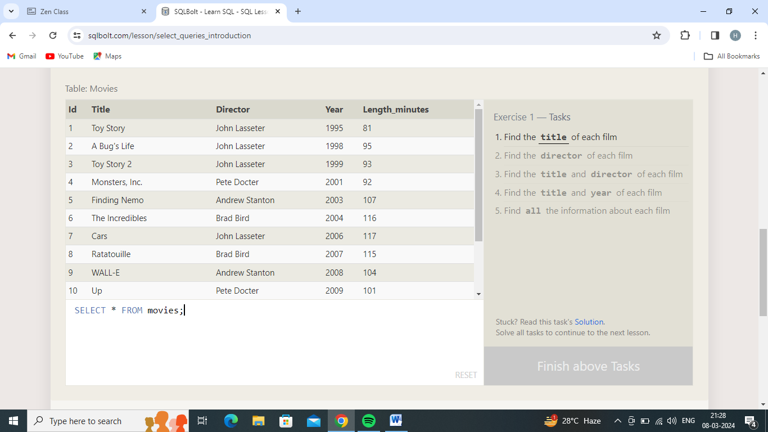

1.Find the **title** of each film

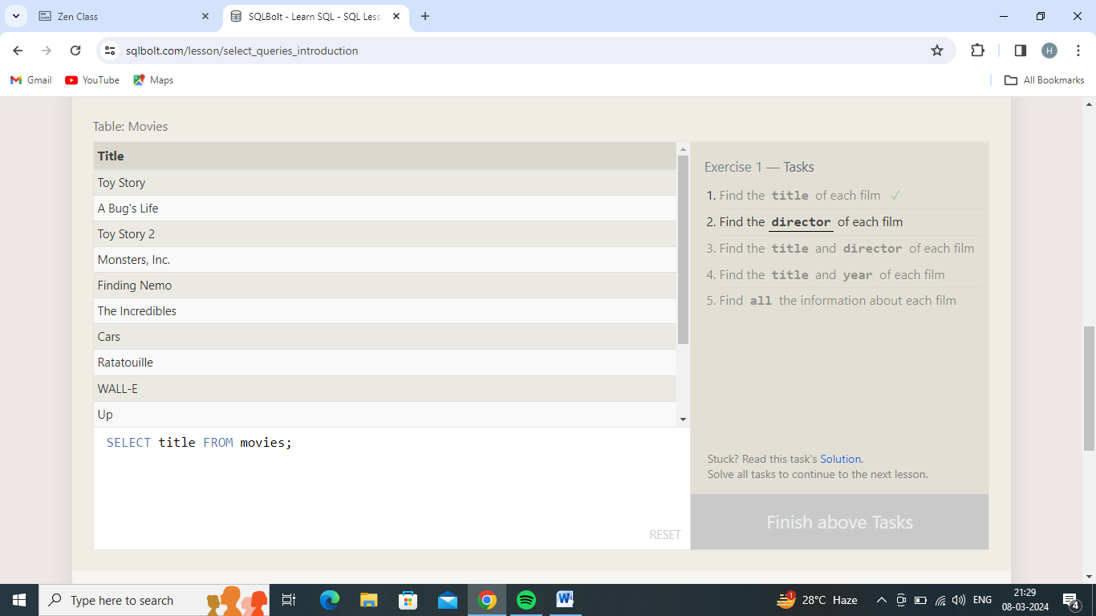

2.Find the **director** of each film

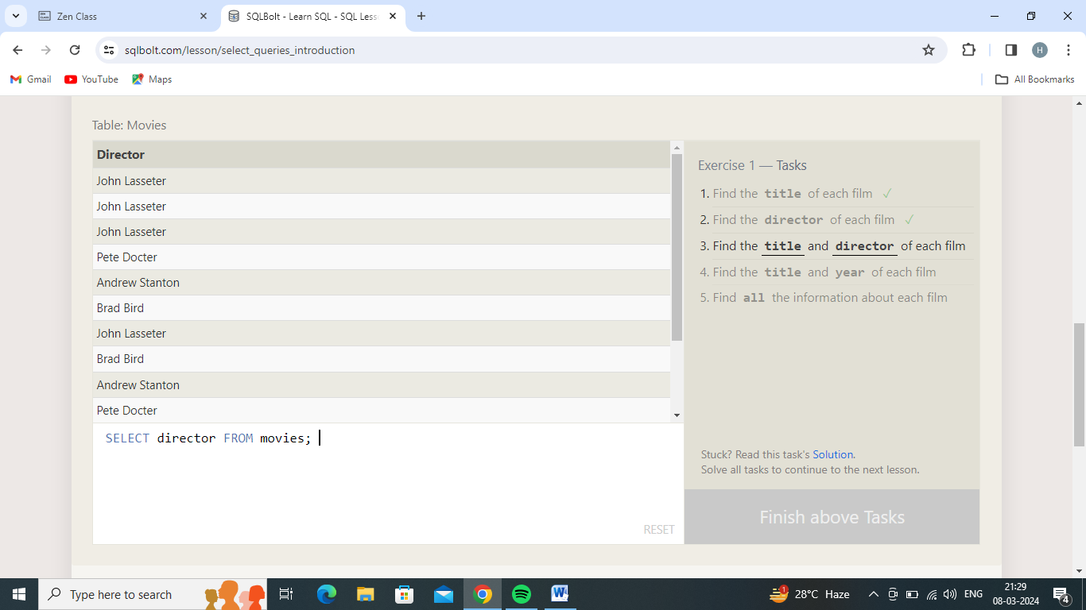

3.Find the **title** and **director** of each film

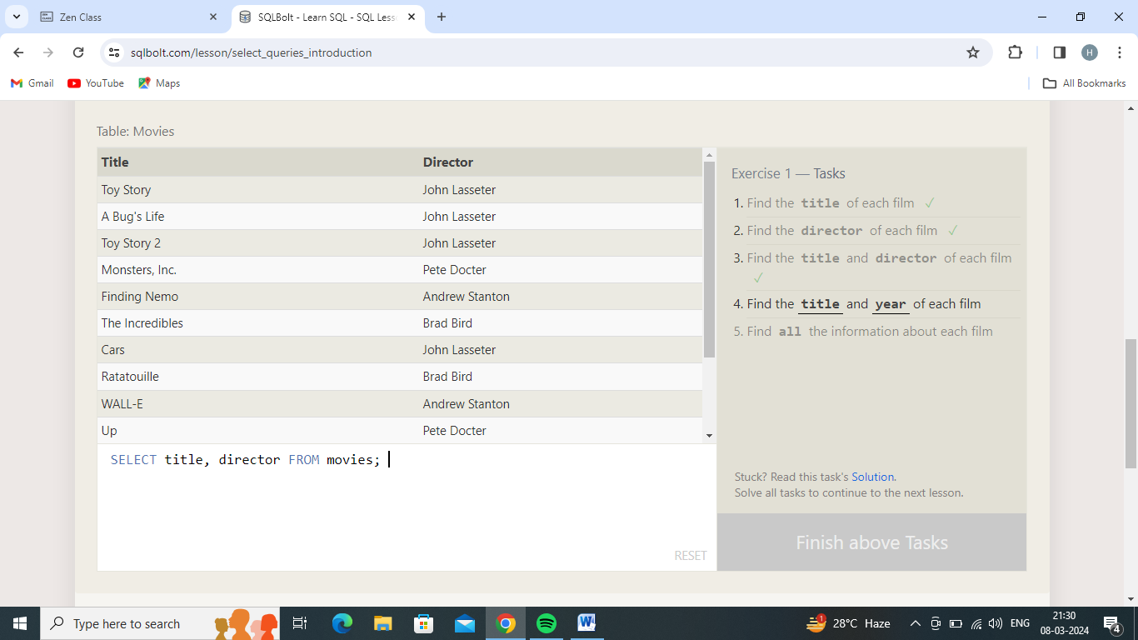

4.Find the **title** and **year** of each film

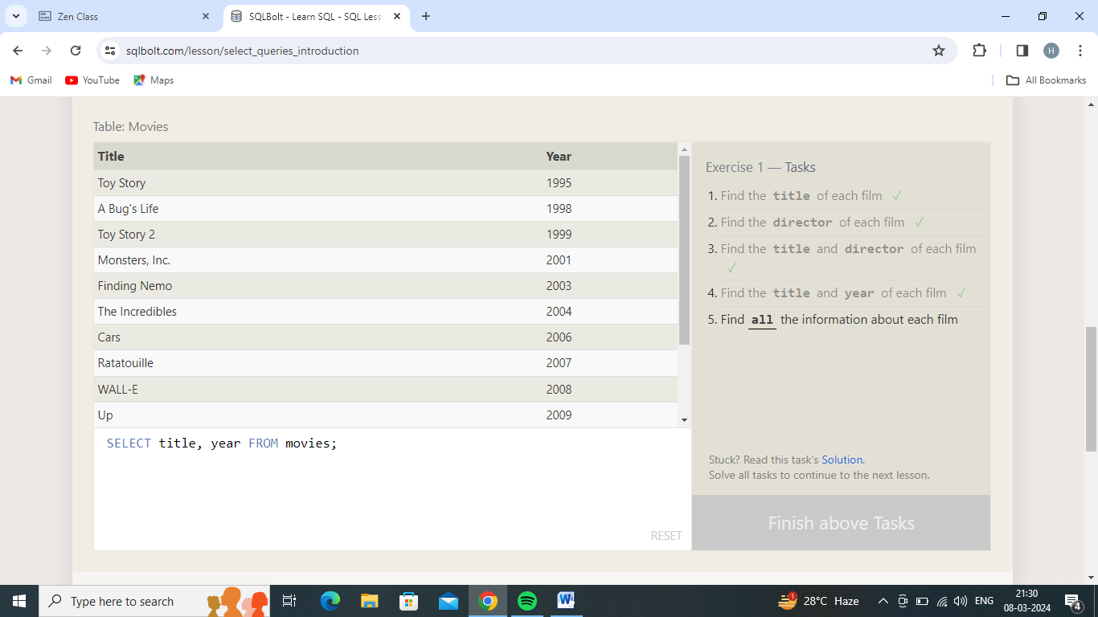

5.Find **all** the information about each film

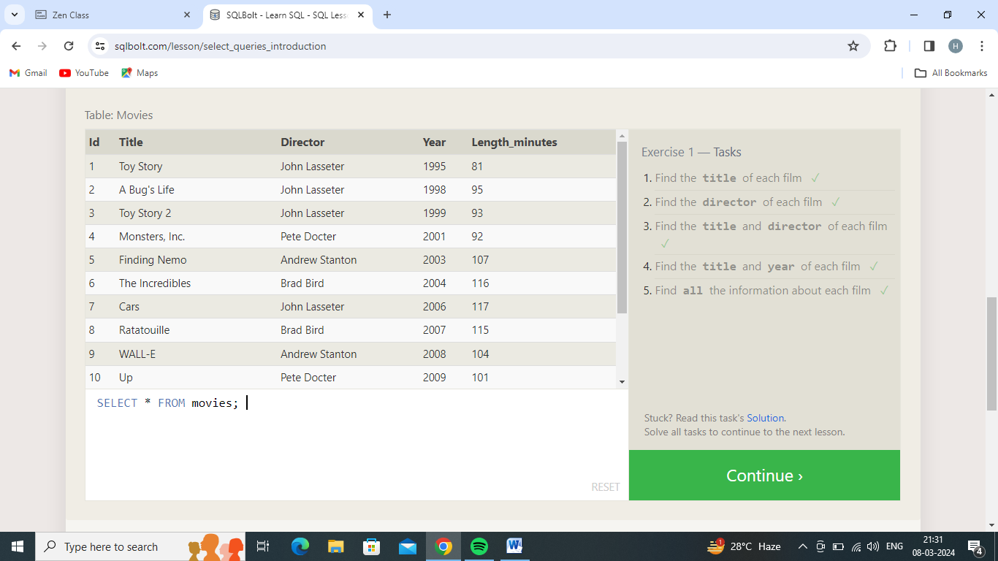

Exercise 2 — Tasks

Table: Movies

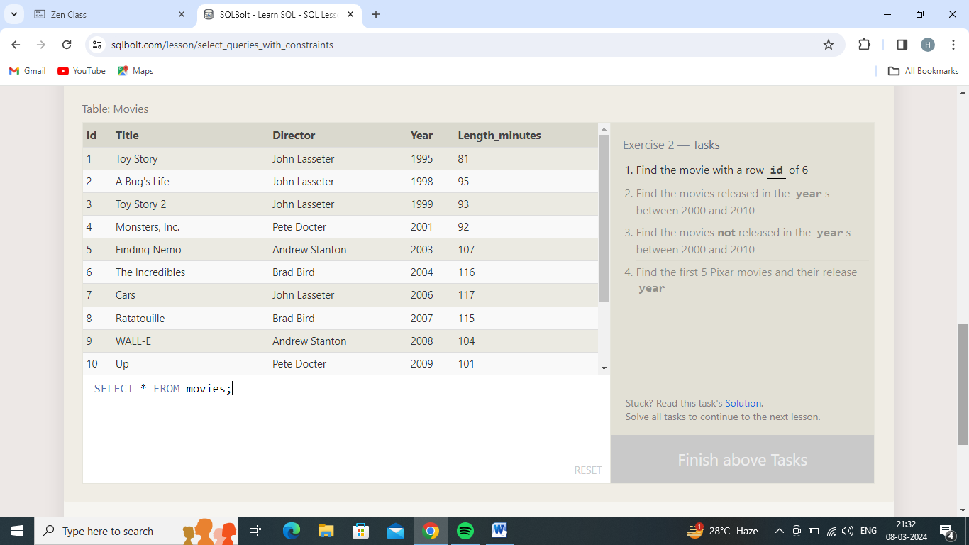

1.Find the movie with a row **id** of 6

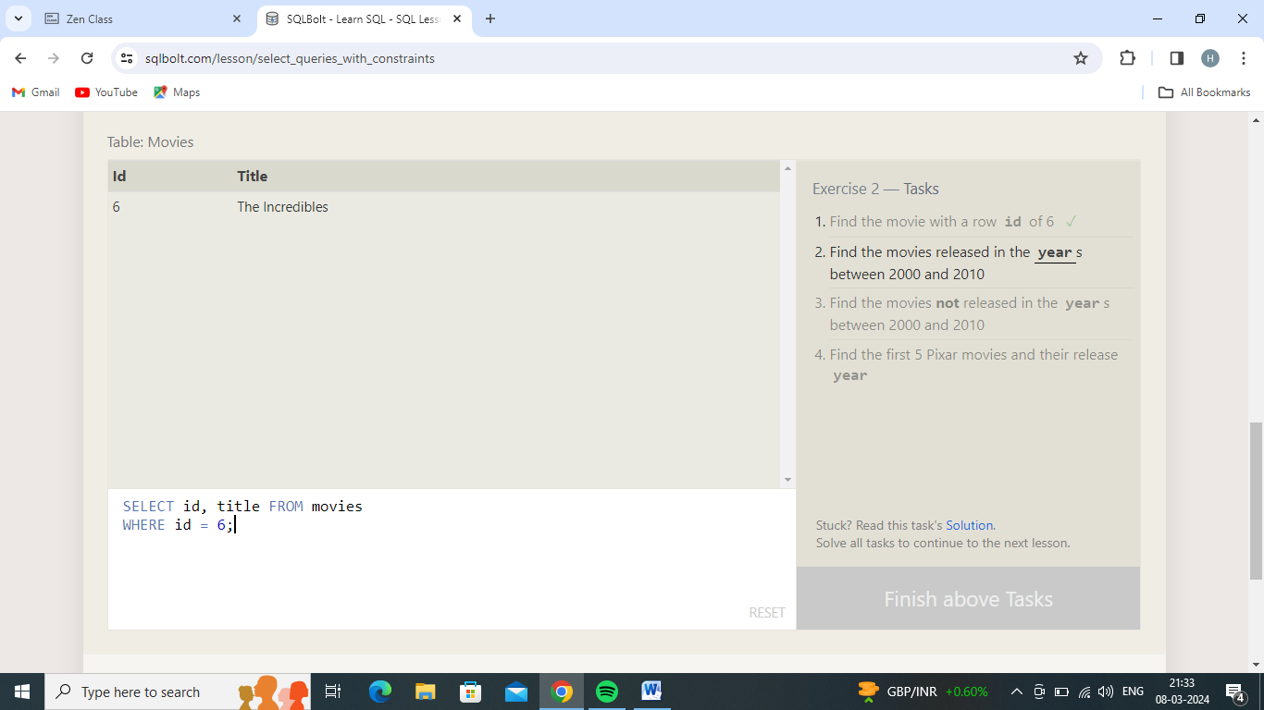

2.Find the movies released in the **year**s between 2000 and 2010

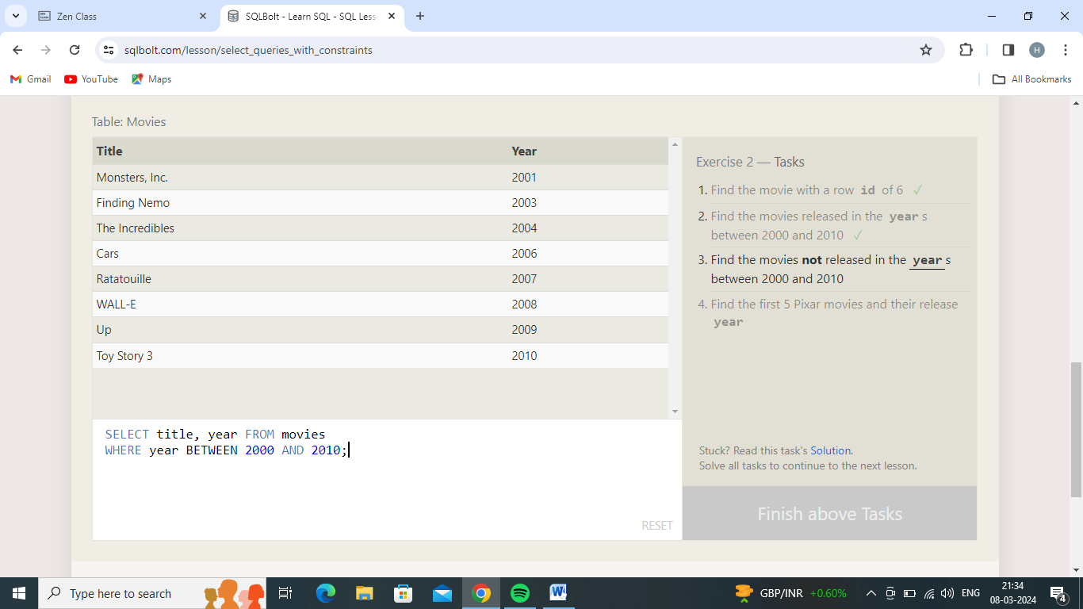

3.Find the movies **not** released in the **year**s between 2000 and 2010

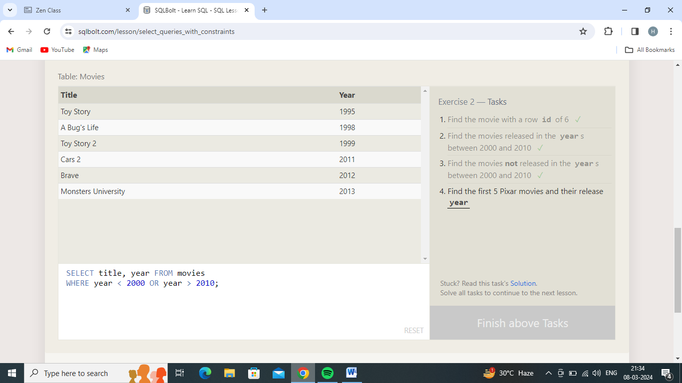

4.Find the first 5 Pixar movies and their release **year**

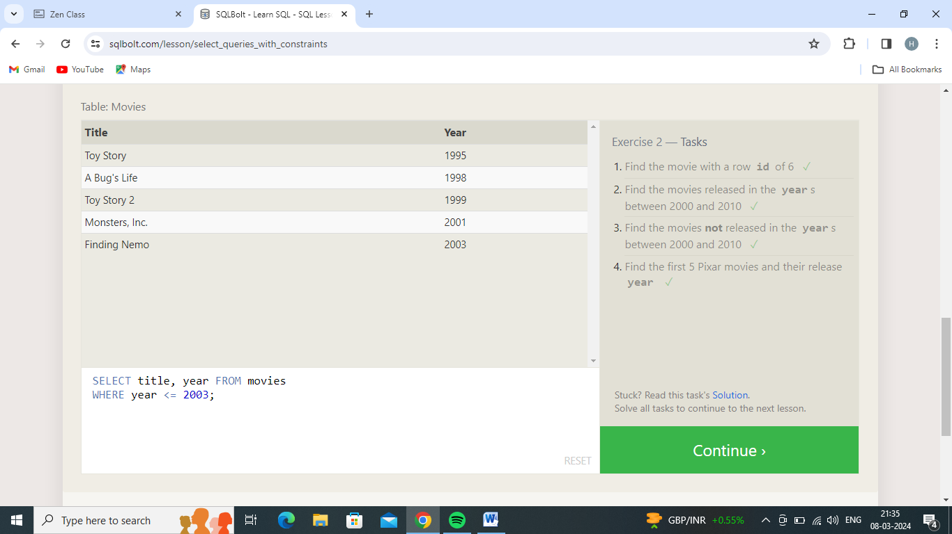

Exercise 3 — Tasks

Table: Movies

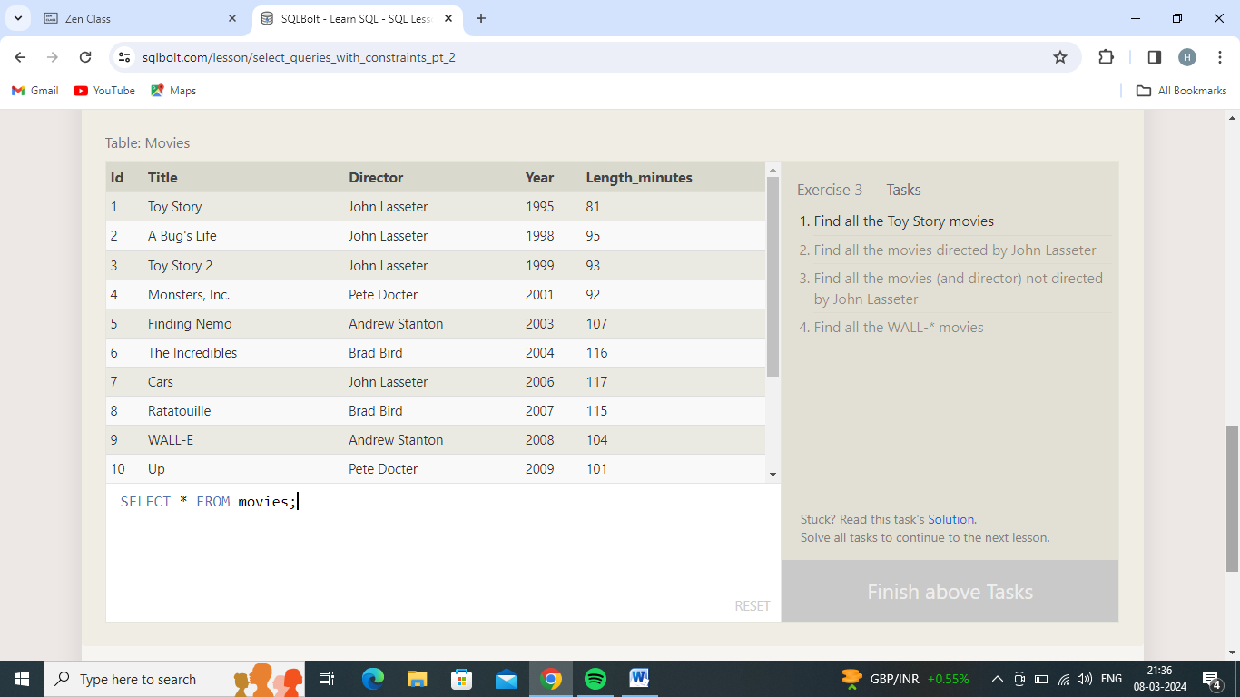

1.Find all the Toy Story movies

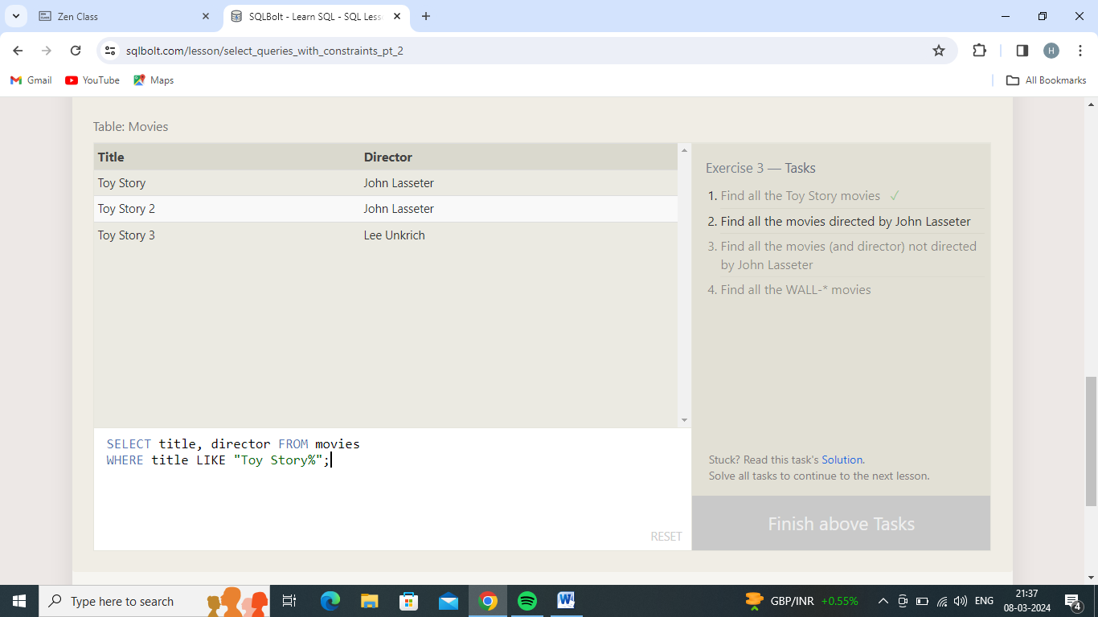

2.Find all the movies directed by John Lasseter

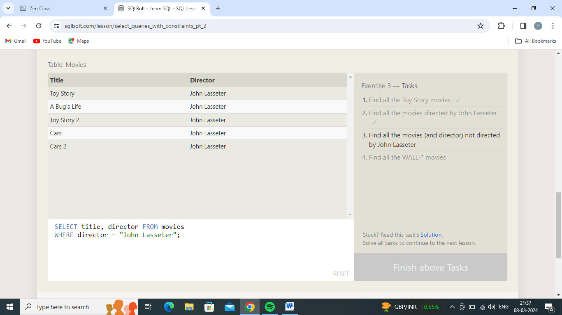

3.Find all the movies (and director) not directed by John Lasseter

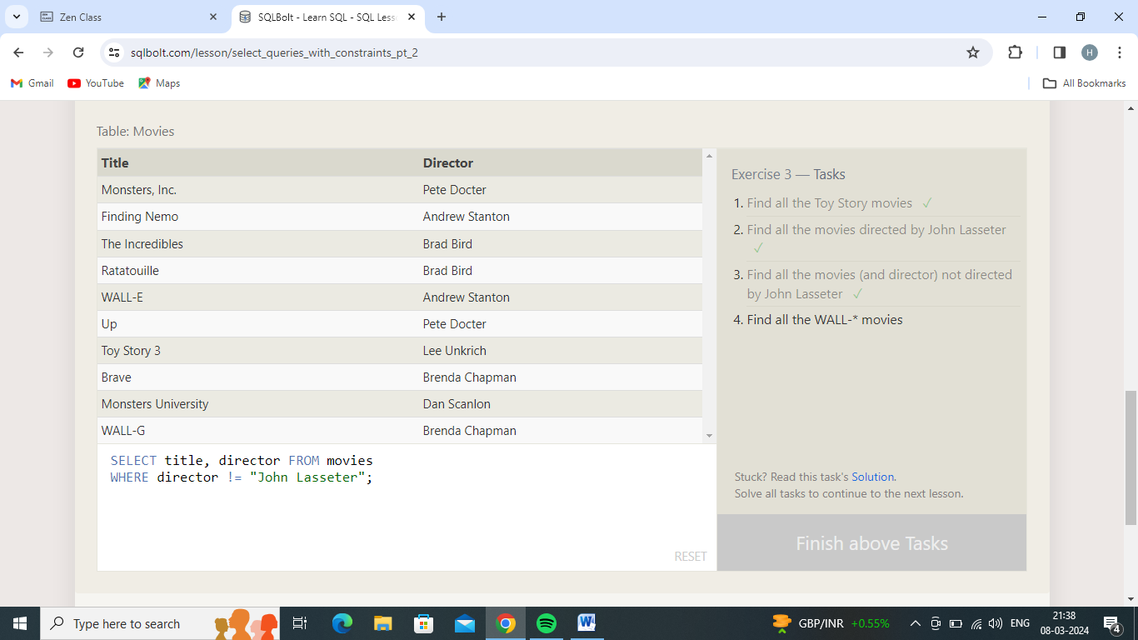

4.Find all the WALL-* movies

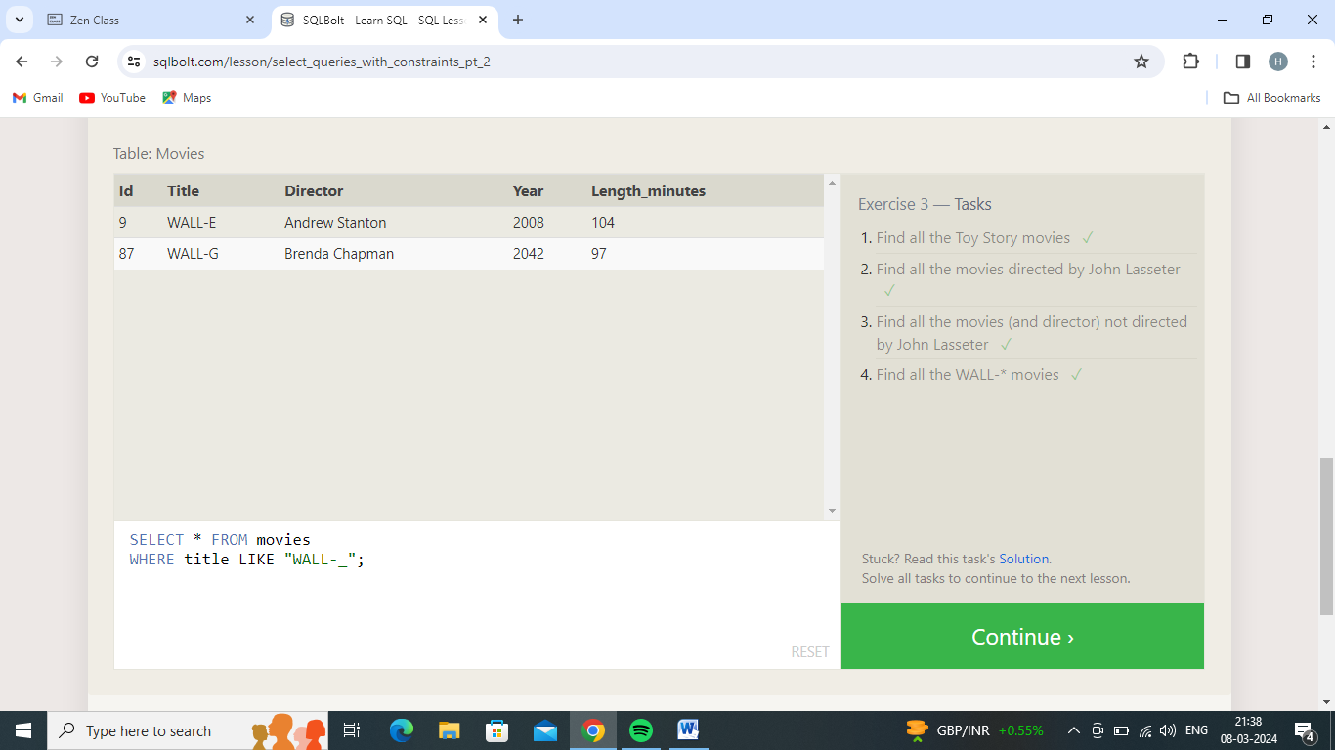

Exercise 4 — Tasks

Table: Movies

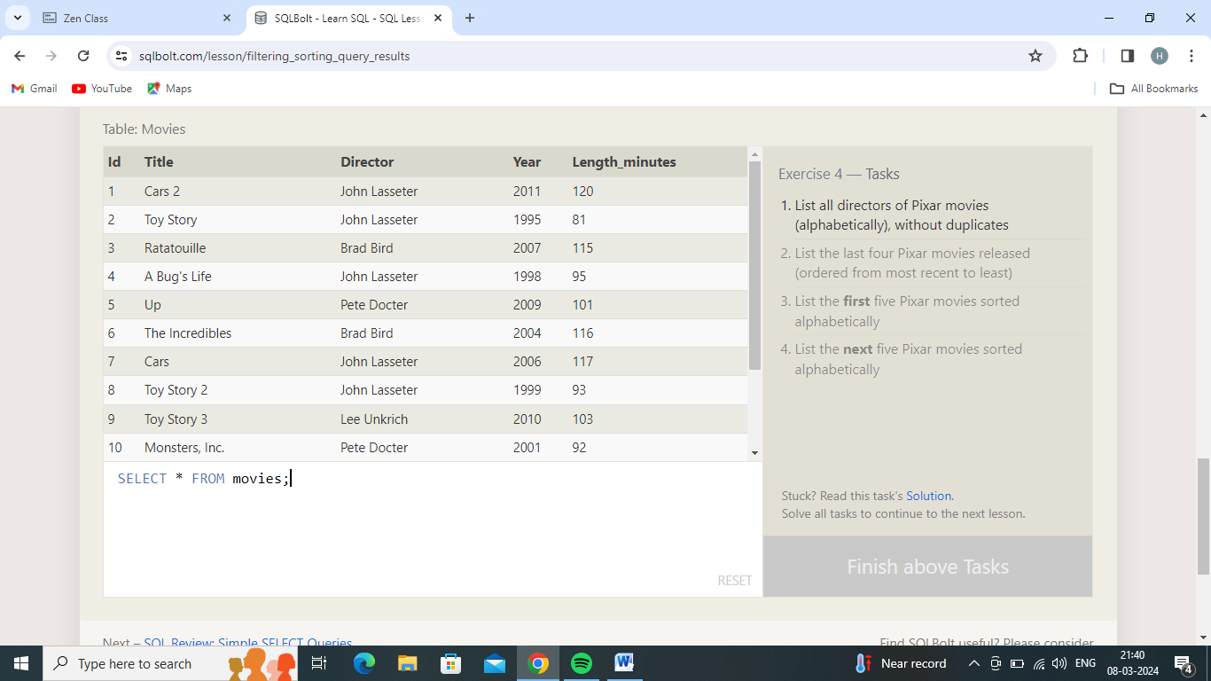

1.List all directors of Pixar movies (alphabetically), without duplicates

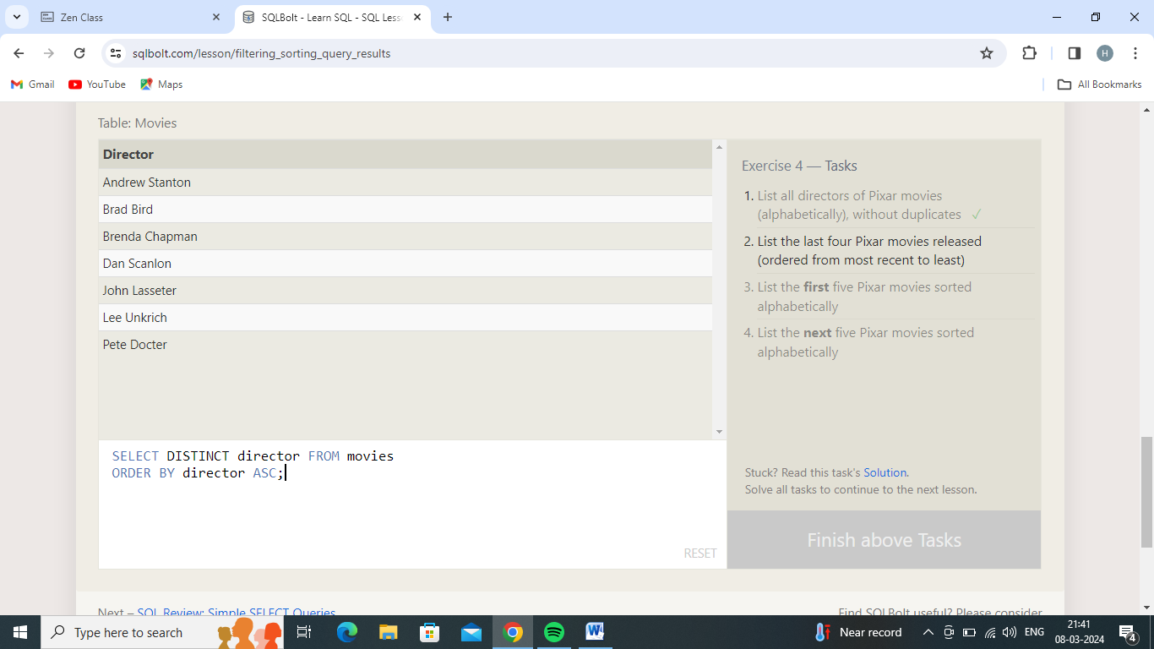

2.List the last four Pixar movies released (ordered from most recent to least)

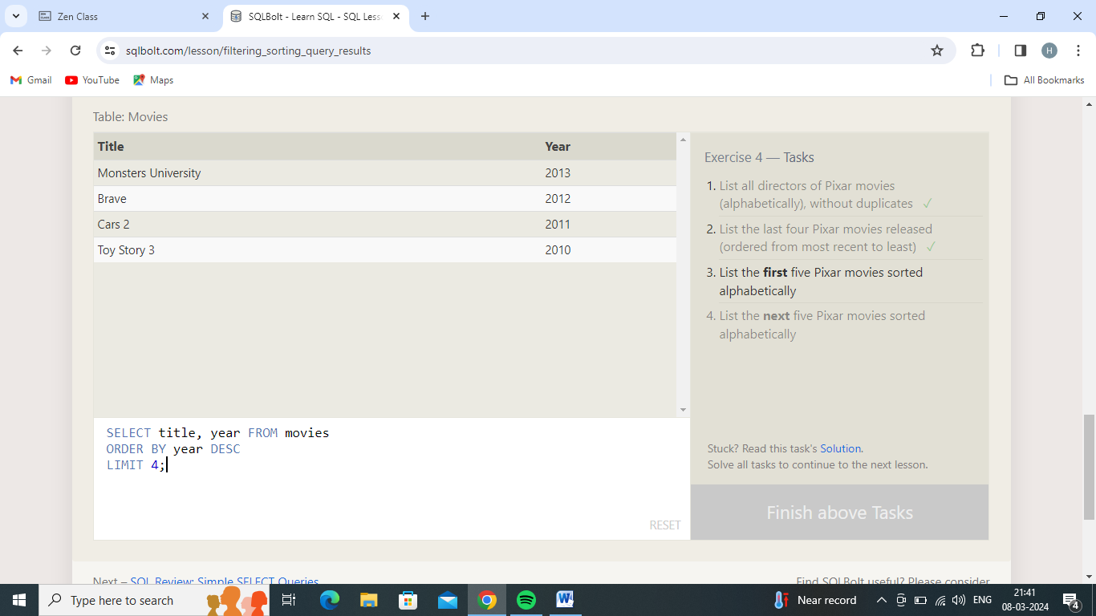

3.List the **first** five Pixar movies sorted alphabetically

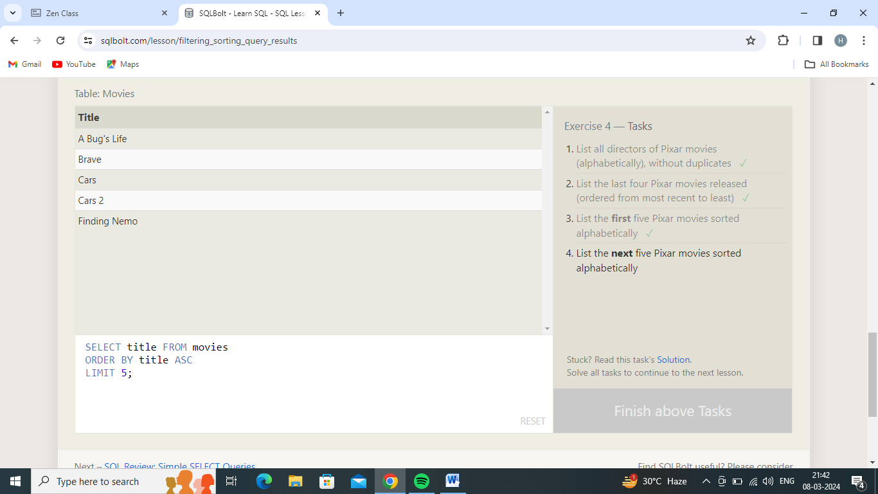

4.List the **next** five Pixar movies sorted alphabetically

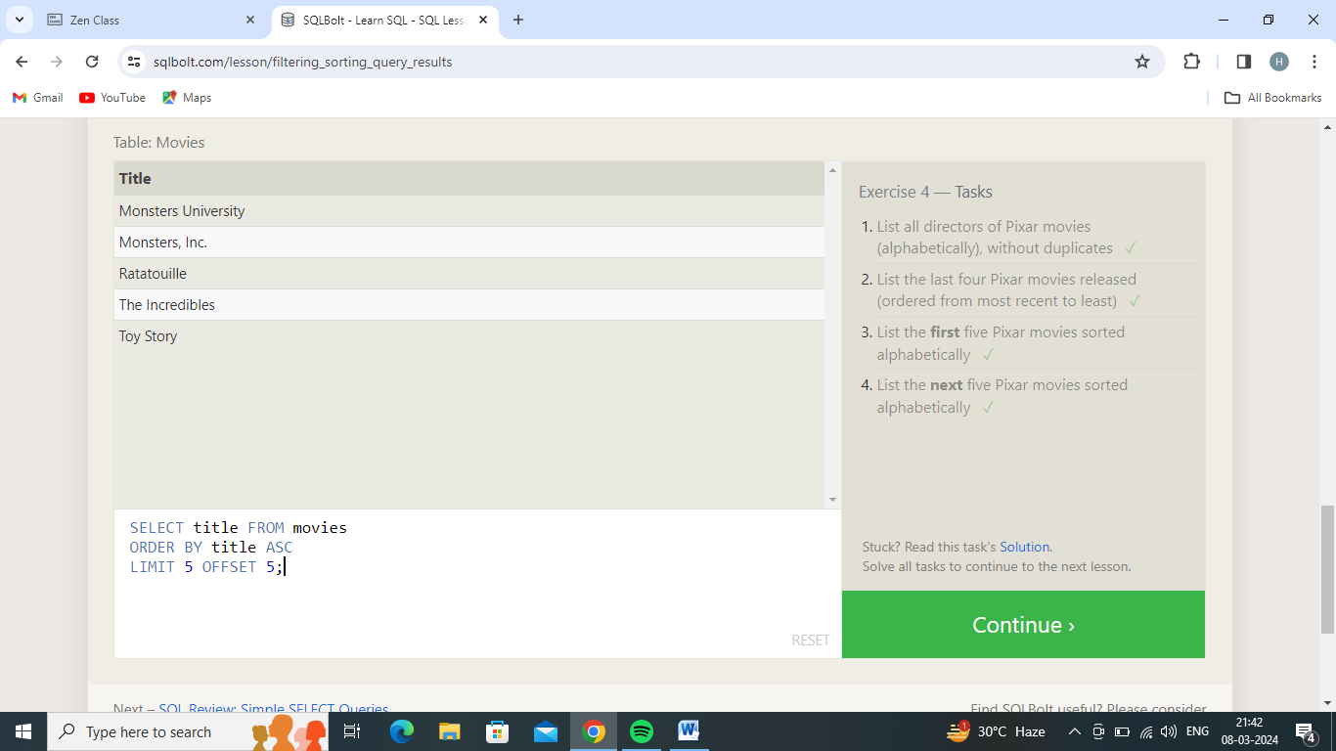

Review 1 — Tasks

Table: North_american_cities

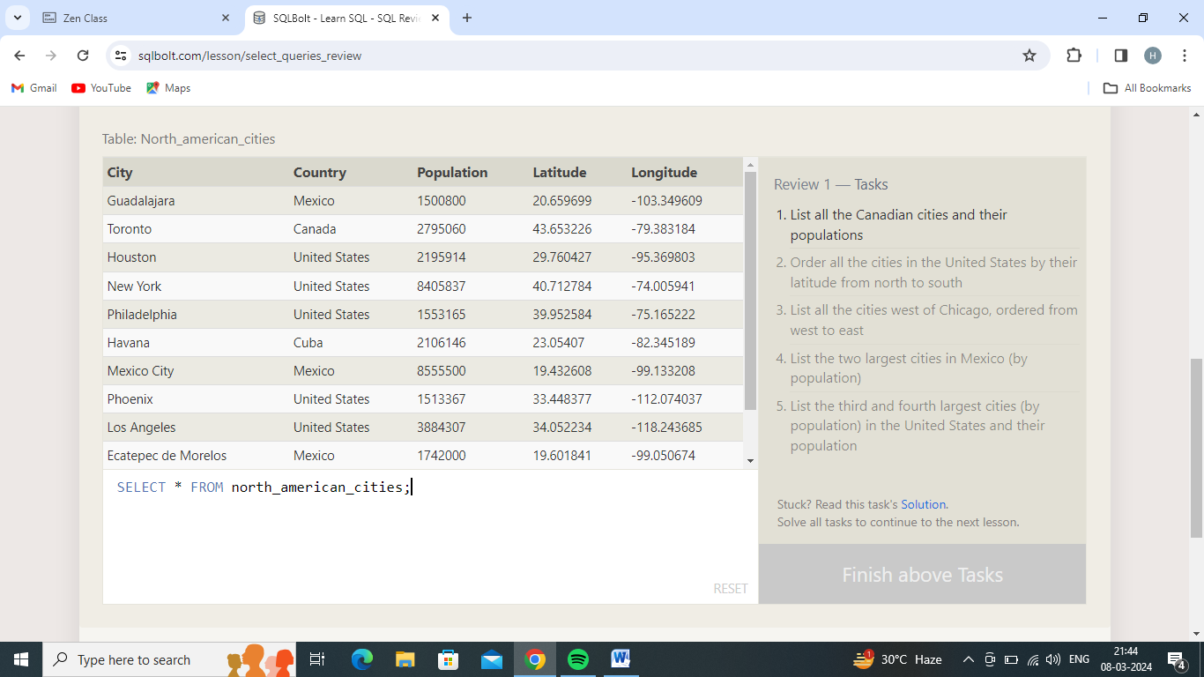

1.List all the Canadian cities and their populations

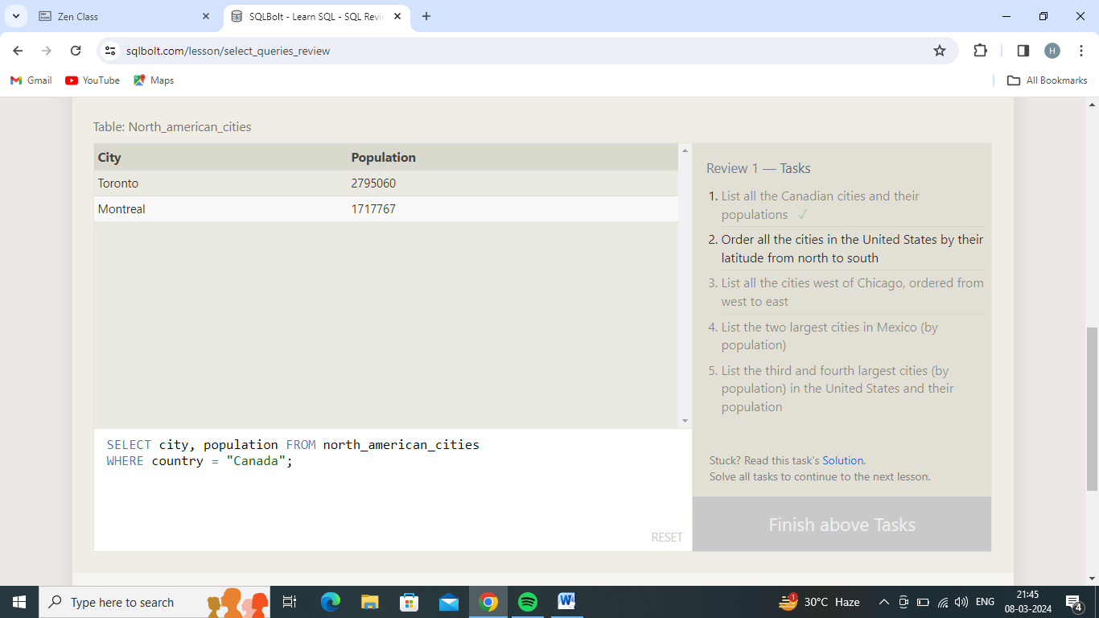

2.Order all the cities in the United States by their latitude from north to south

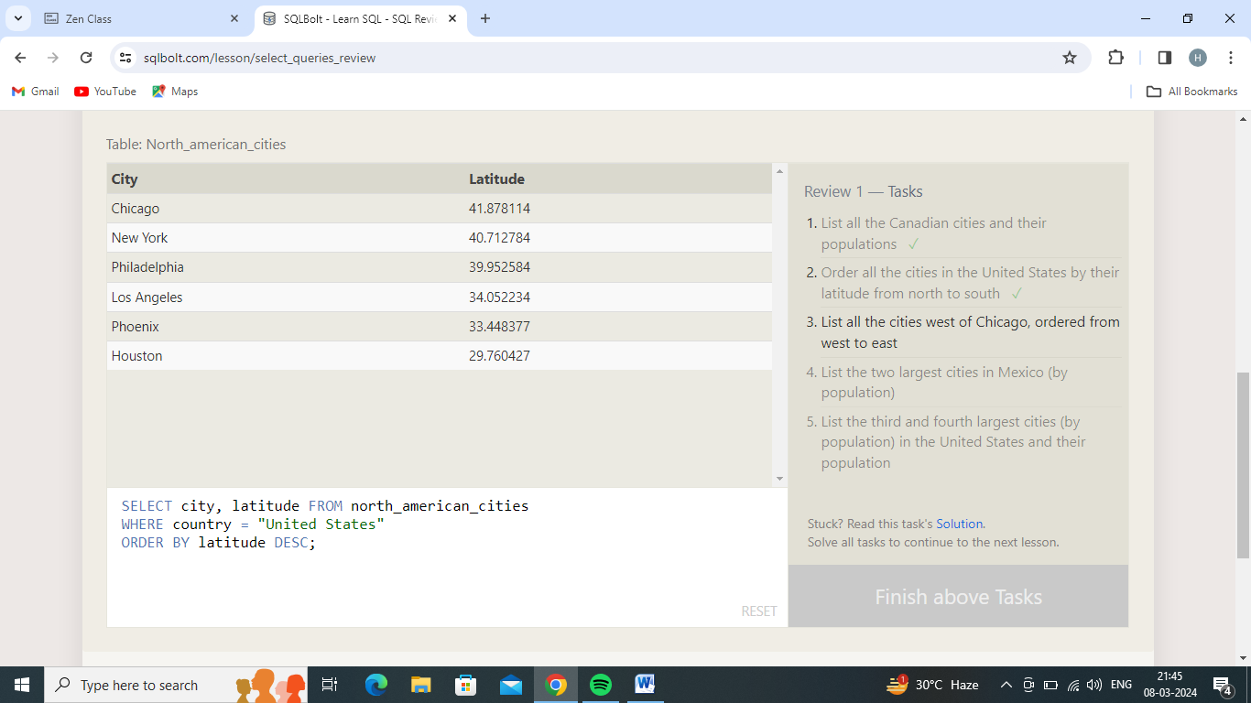

3.List all the cities west of Chicago, ordered from west to east

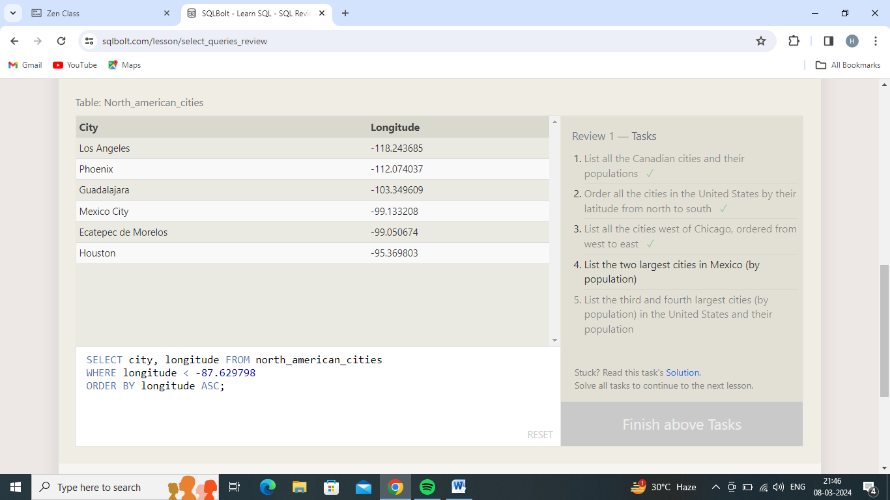

4.List the two largest cities in Mexico (by population)

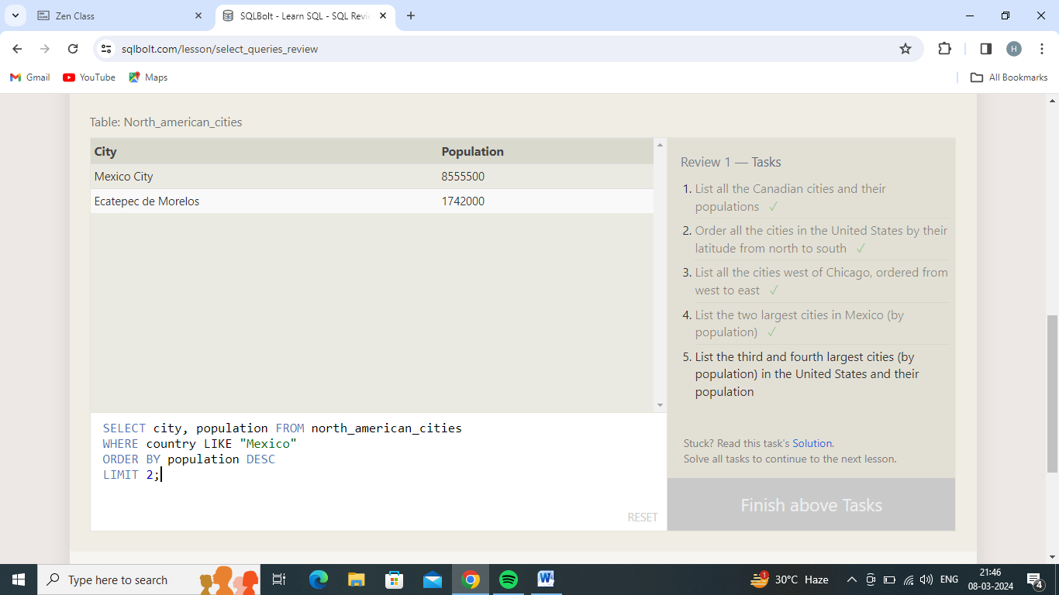

5.List the third and fourth largest cities (by population) in the United States and their population

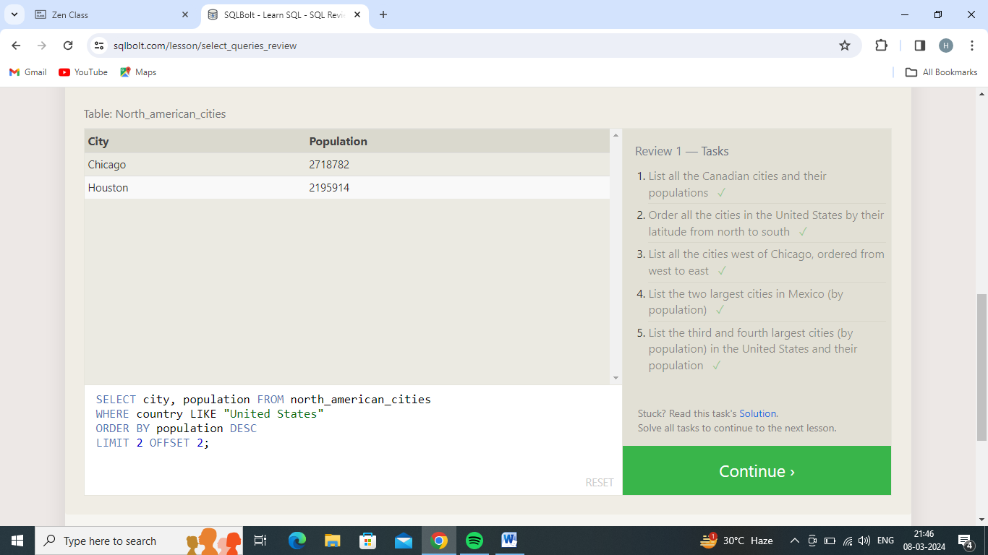

Exercise 6 — Tasks

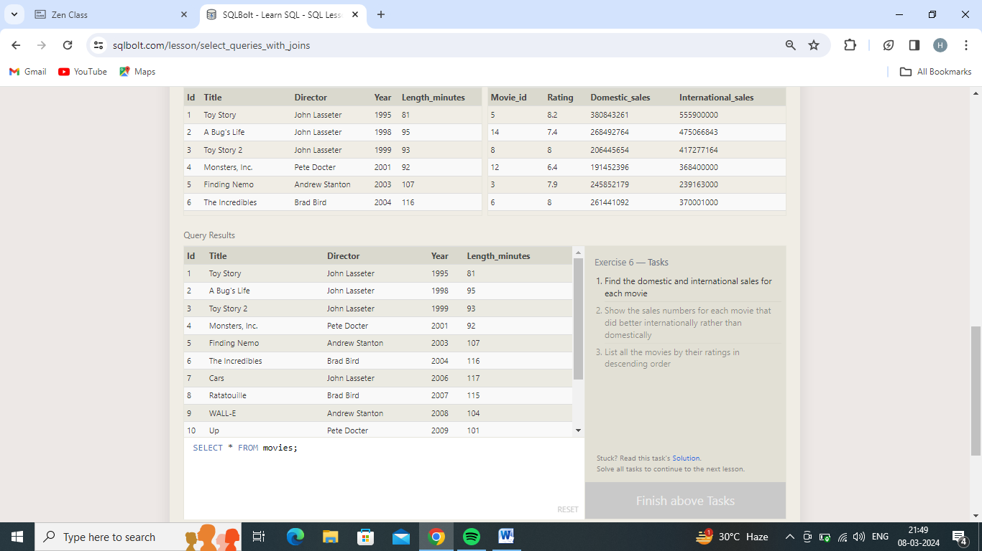

1.Find the domestic and international sales for each movie

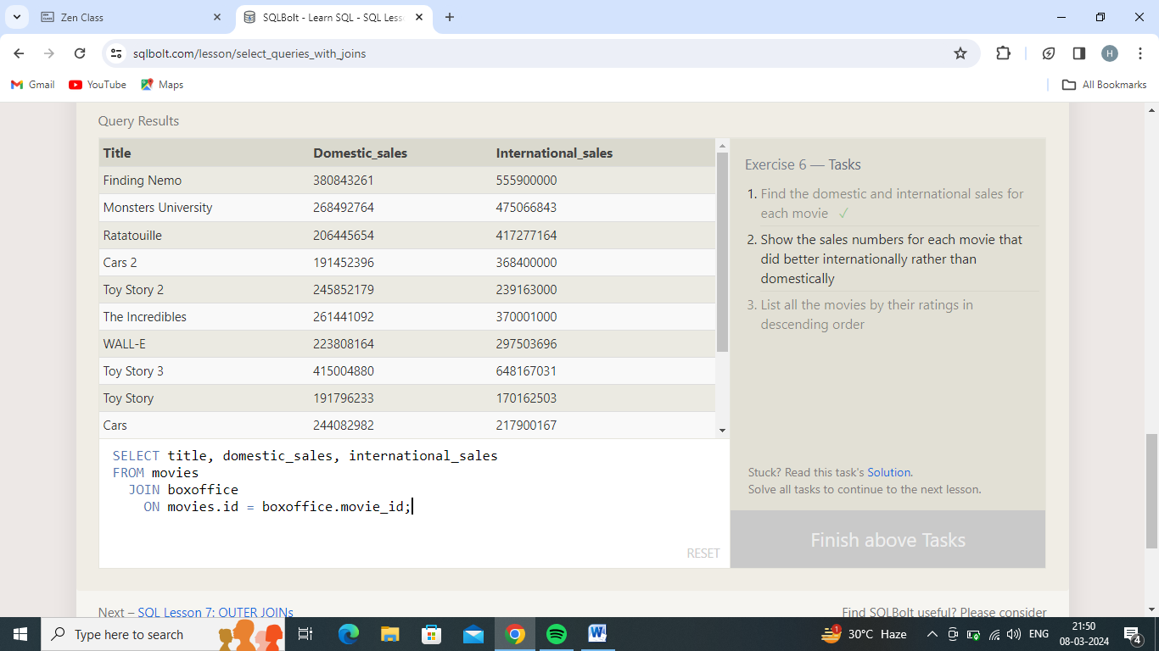

2.Show the sales numbers for each movie that did better internationally rather than domestically

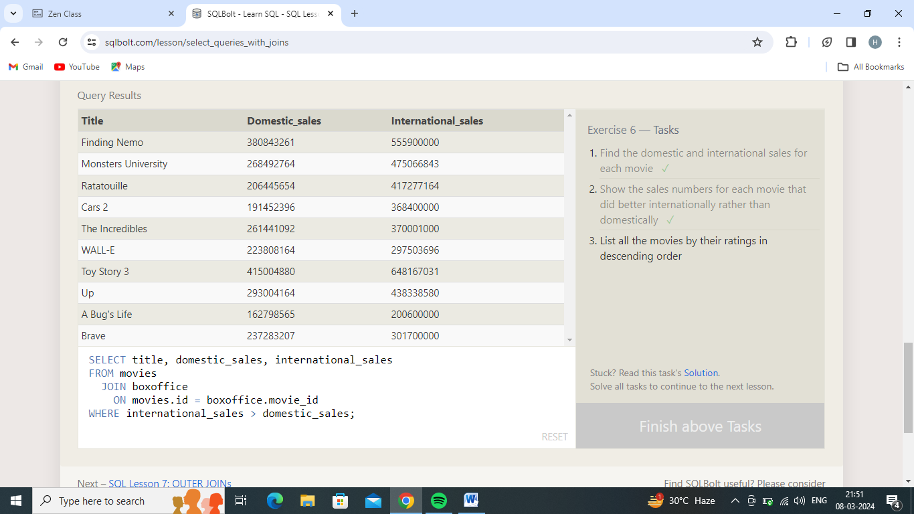

3.List all the movies by their ratings in descending order

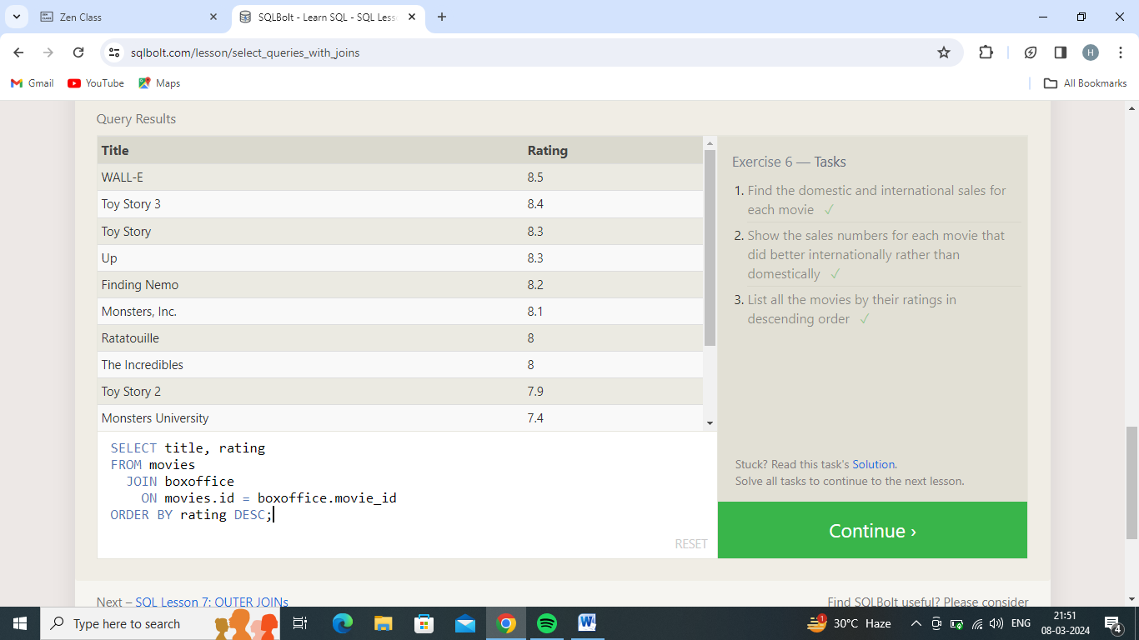

Exercise 7 — Tasks

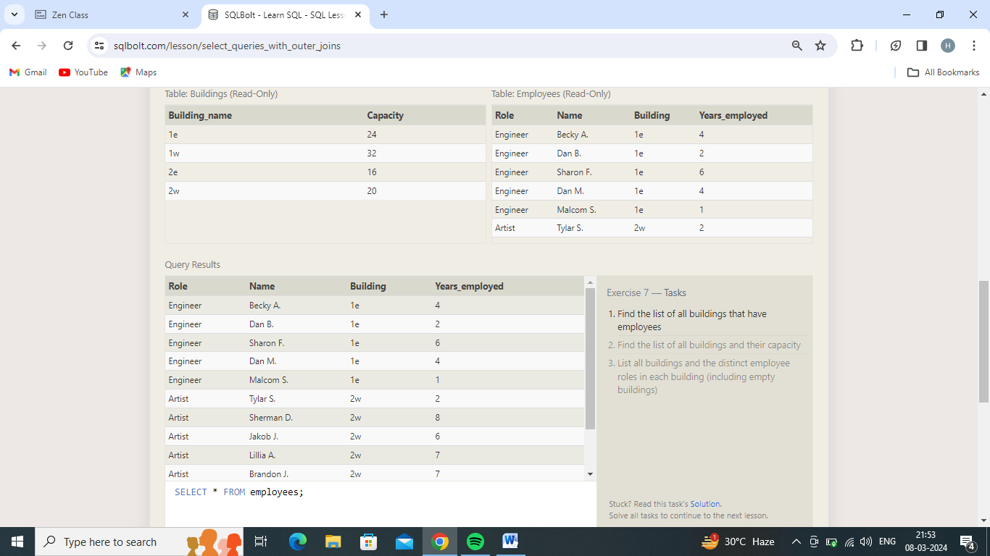

1.Find the list of all buildings that have employees

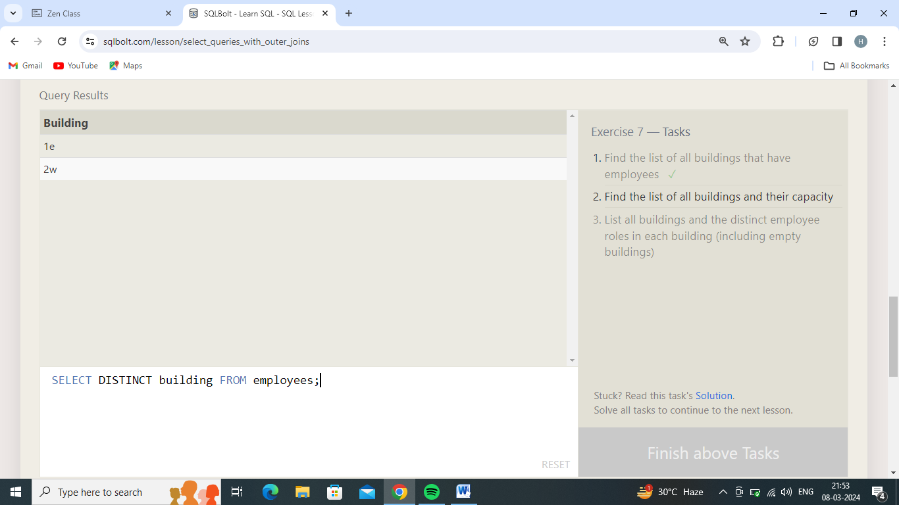

2.Find the list of all buildings and their capacity

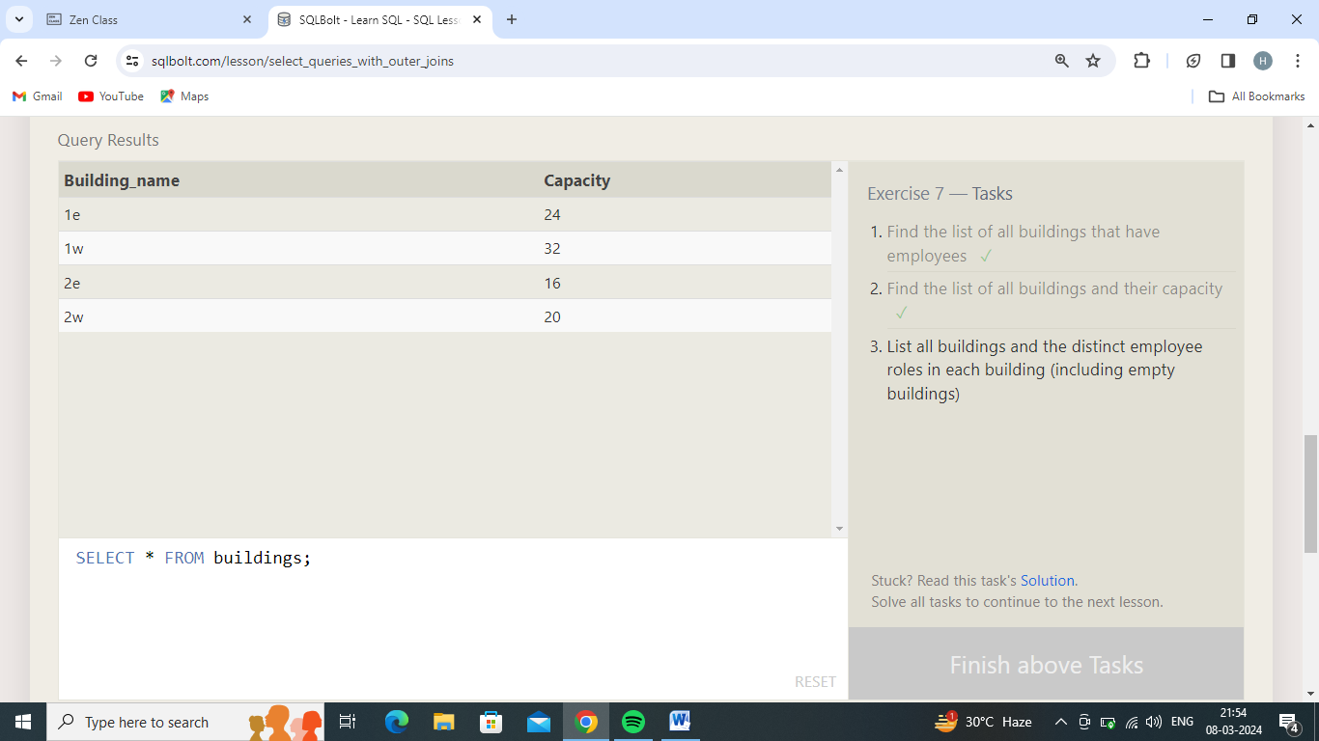

3.List all buildings and the distinct employee roles in each building (including empty buildings)

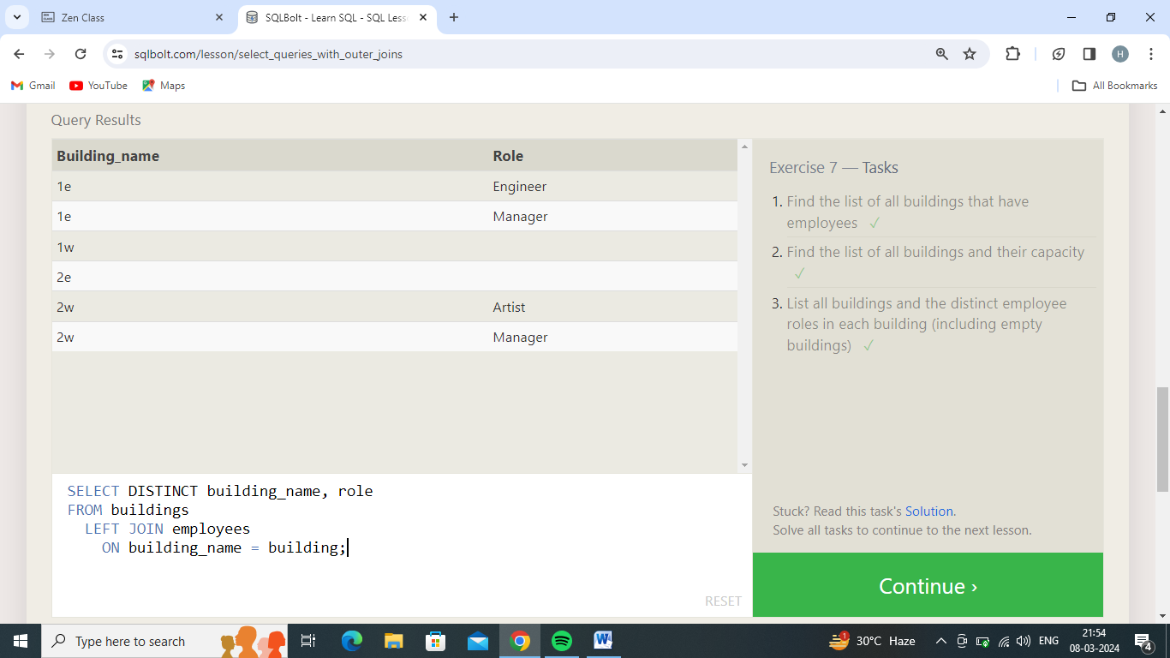

Exercise 8 — Tasks

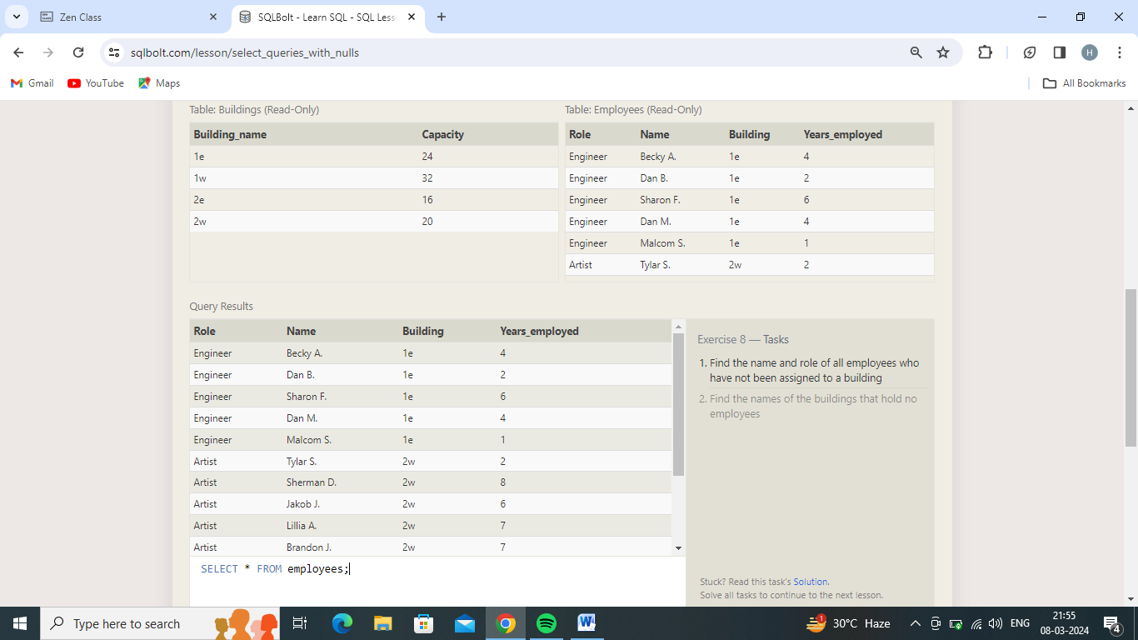

1.Find the name and role of all employees who have not been assigned to a building

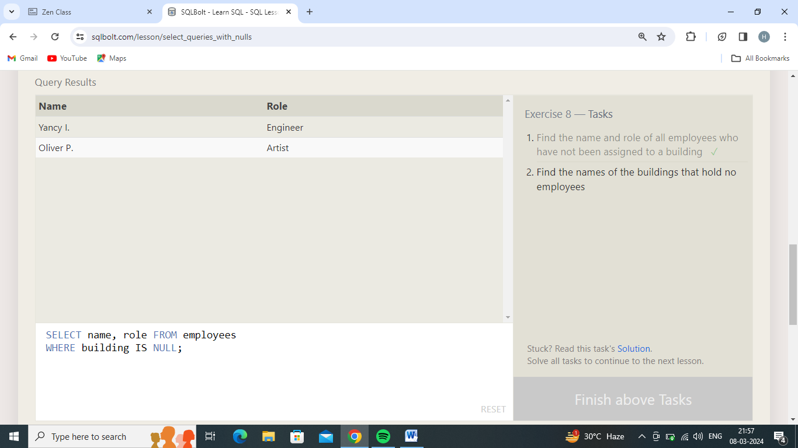

2.Find the names of the buildings that hold no employees

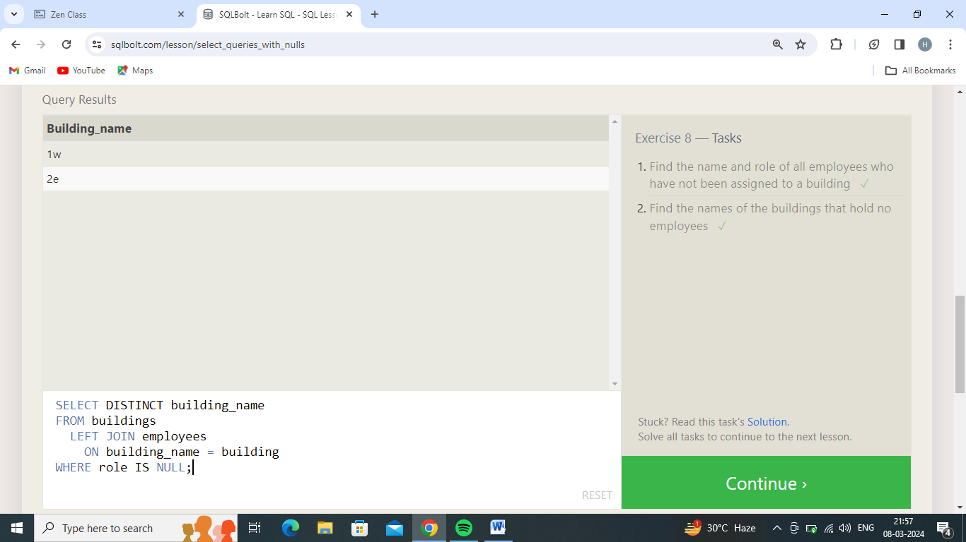

Exercise 9 — Tasks

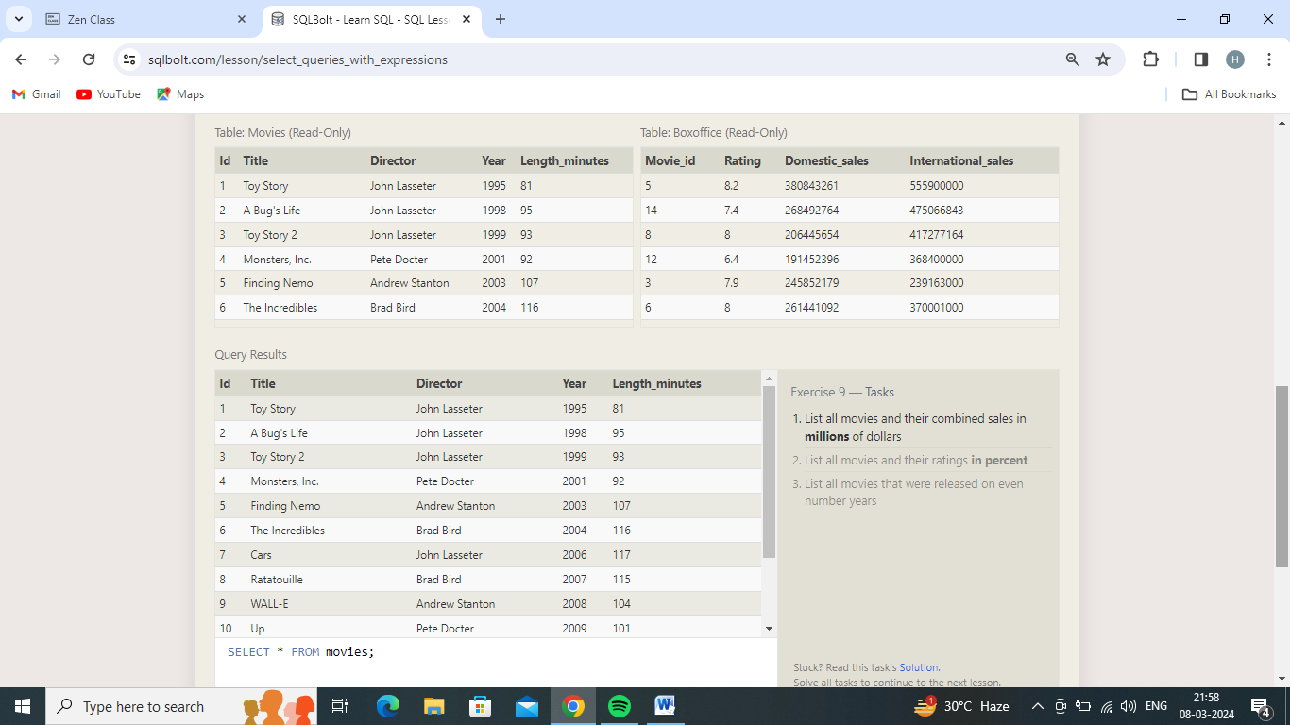

1.List all movies and their combined sales in **millions** of dollars

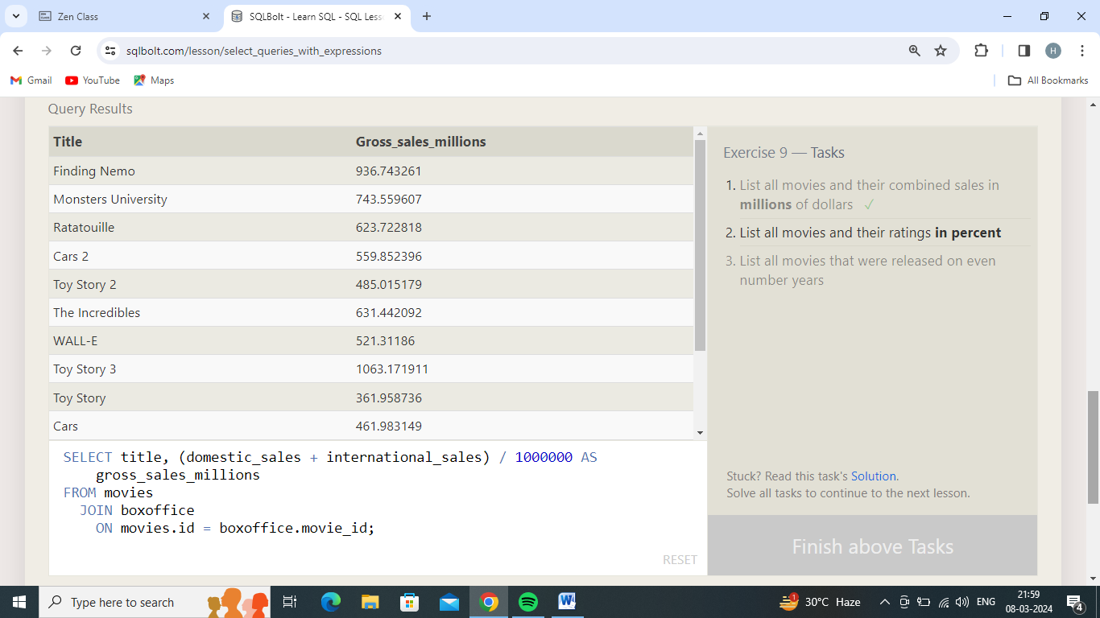

2.List all movies and their ratings **in percent**

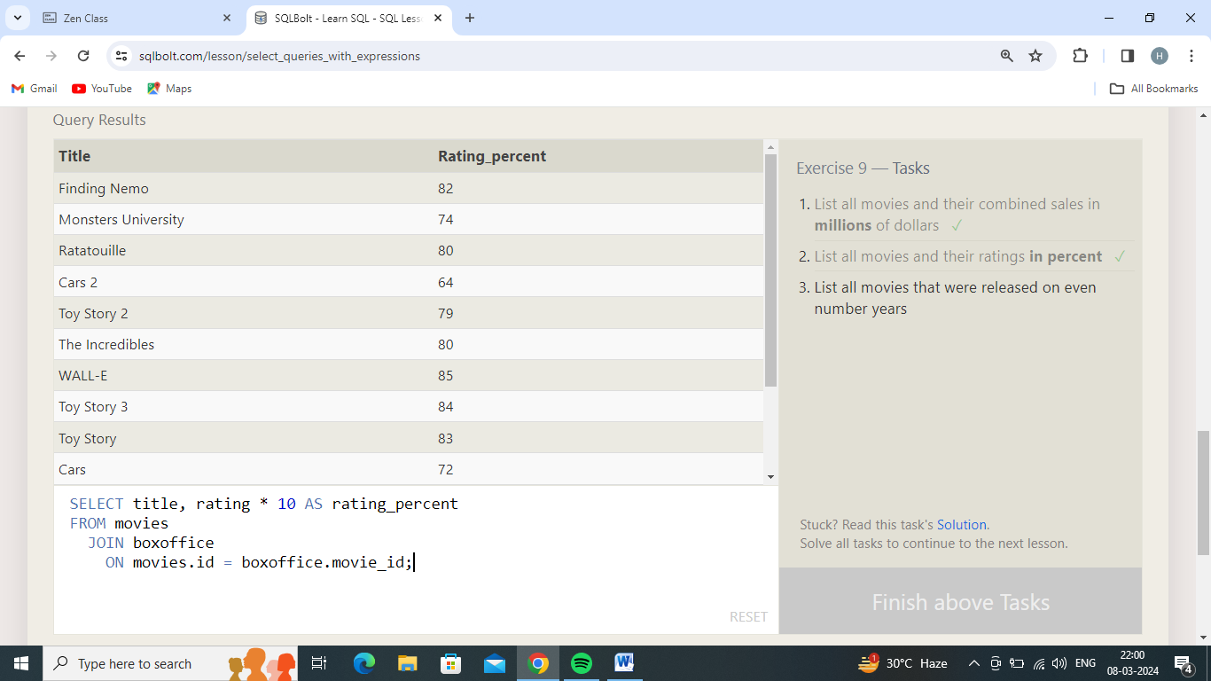

3.List all movies that were released on even number years

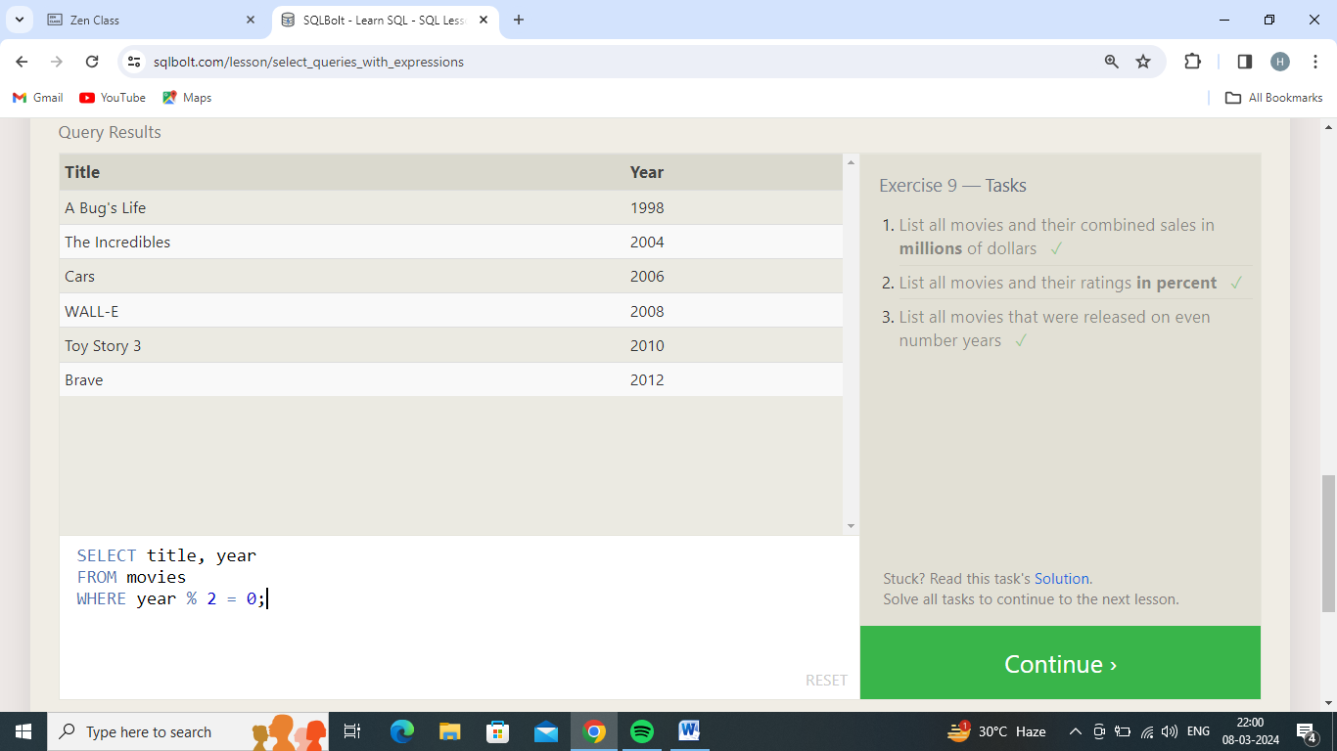

Exercise 10 — Tasks

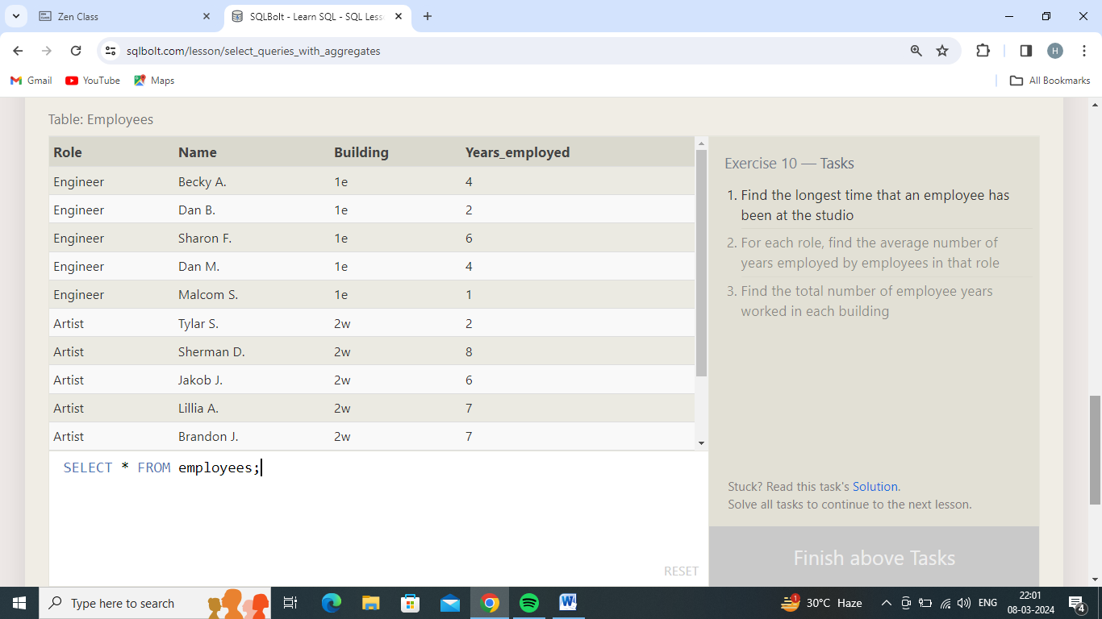

1.Find the longest time that an employee has been at the studio

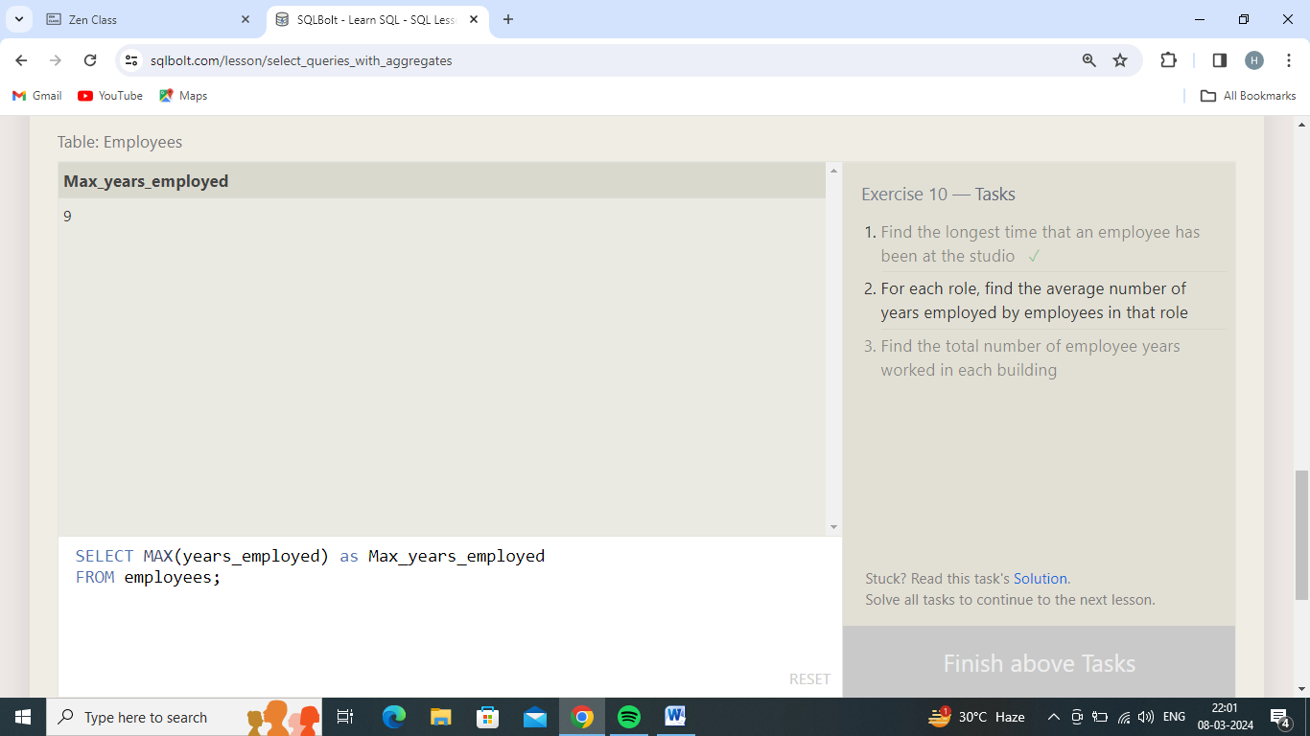

2.For each role, find the average number of years employed by employees in that role

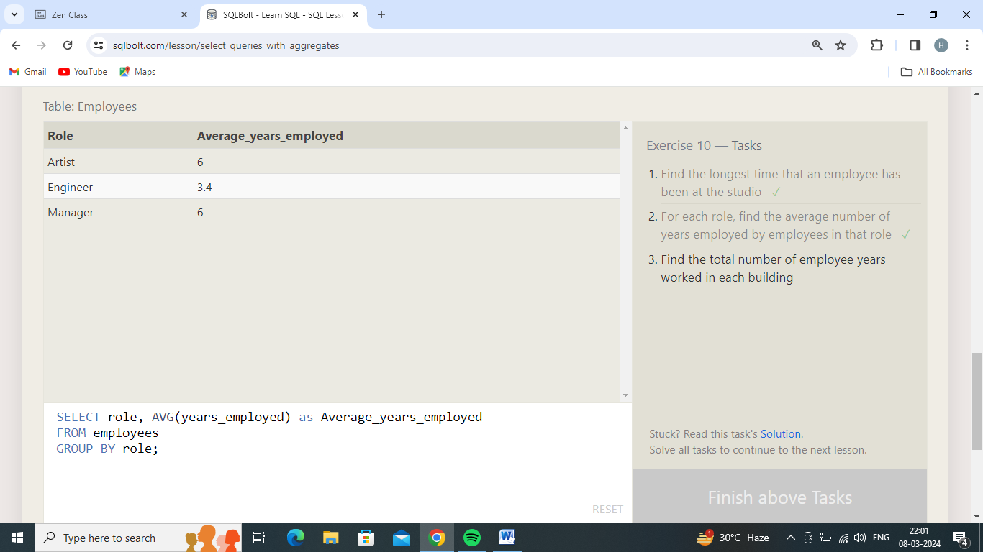

3.Find the total number of employee years worked in each building

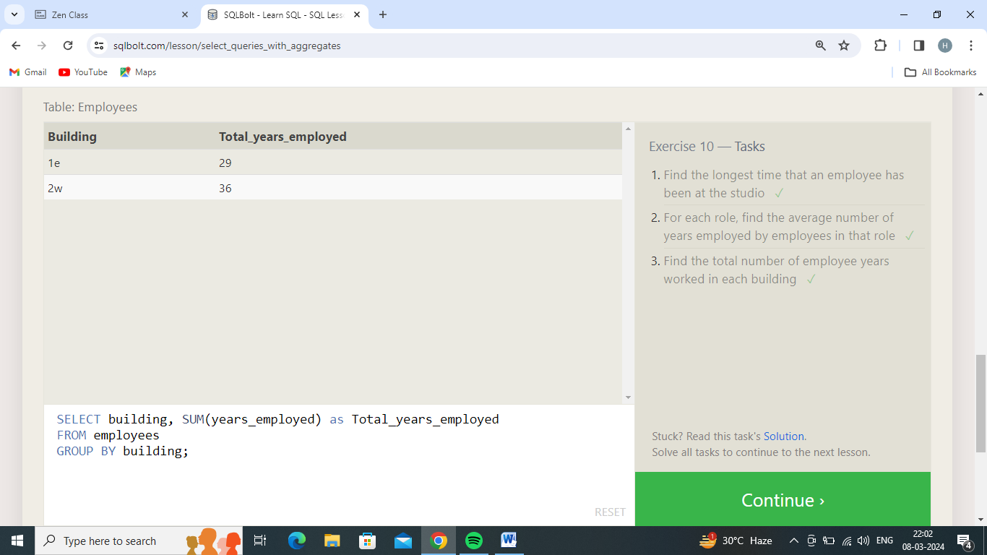

Exercise 11 — Tasks

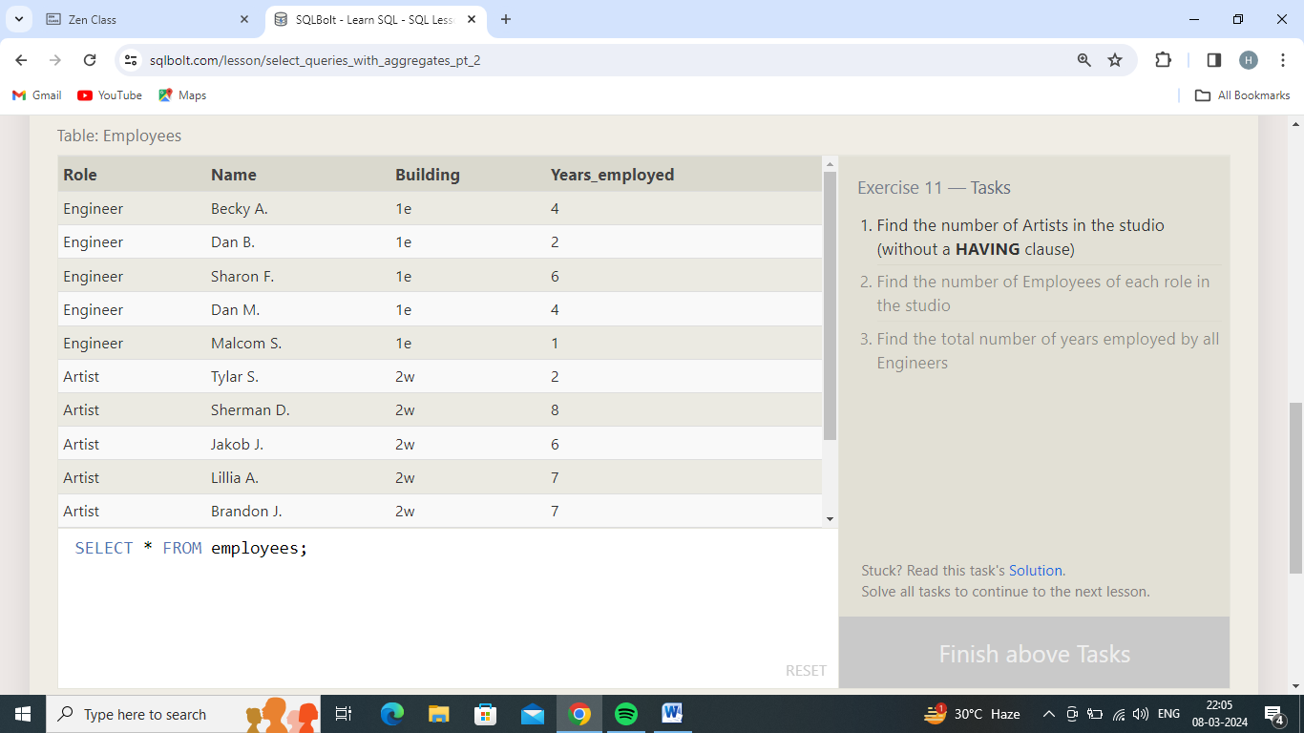

1.Find the number of Artists in the studio (without a **HAVING** clause)

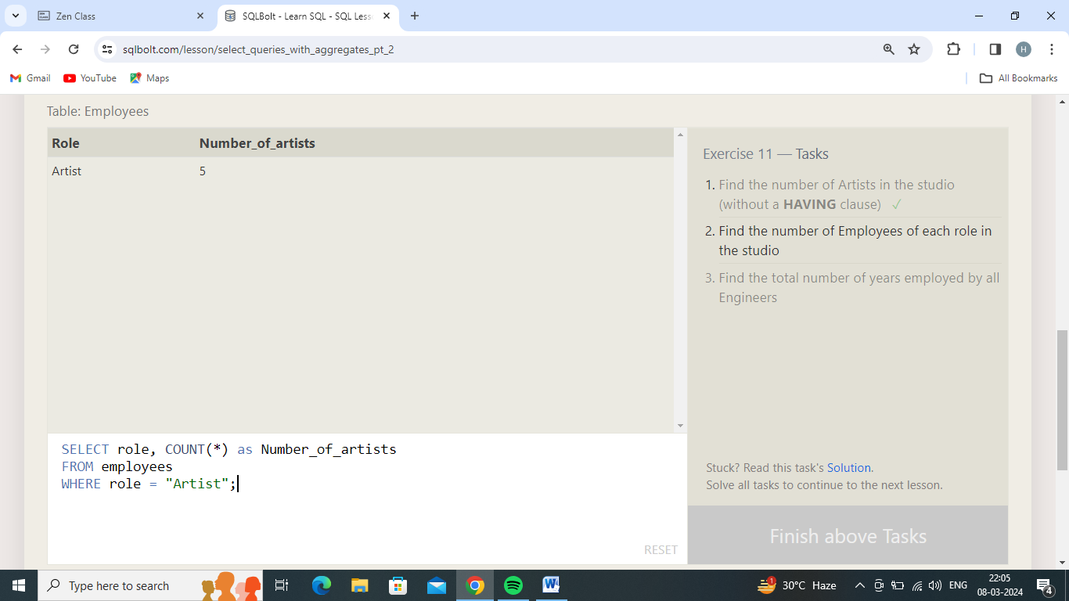

2.Find the number of Employees of each role in the studio

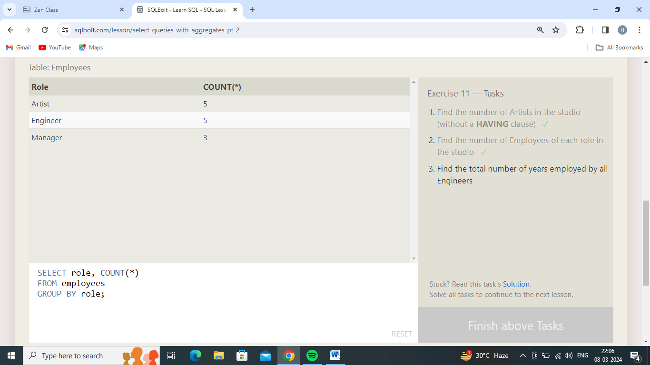

3.Find the total number of years employed by all Engineers

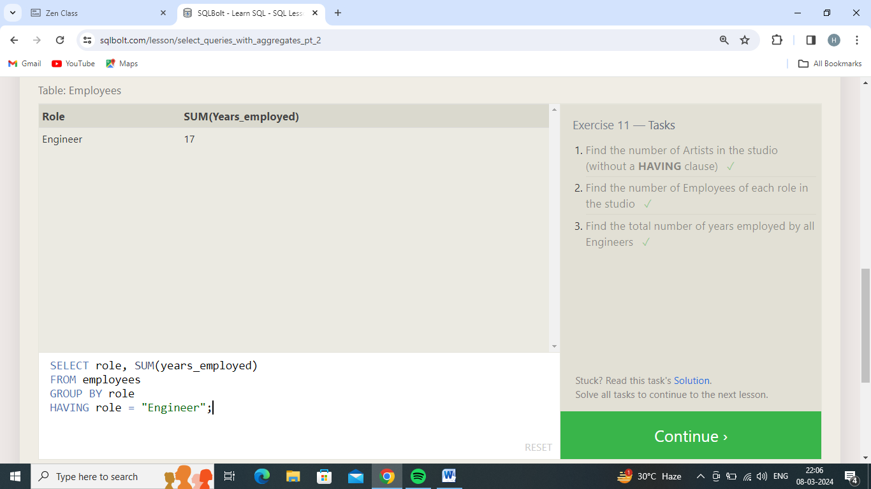

Exercise 12 — Tasks

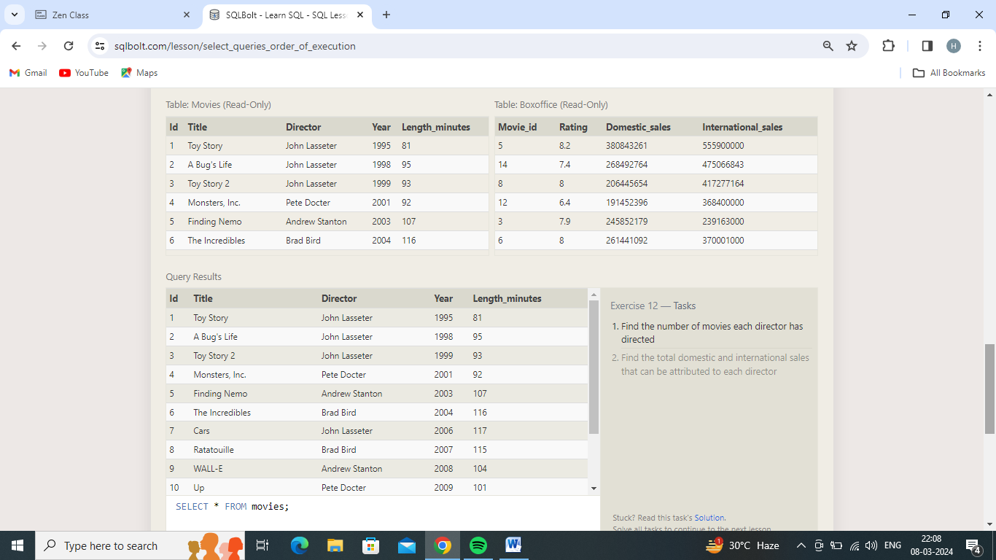

1.Find the number of movies each director has directed

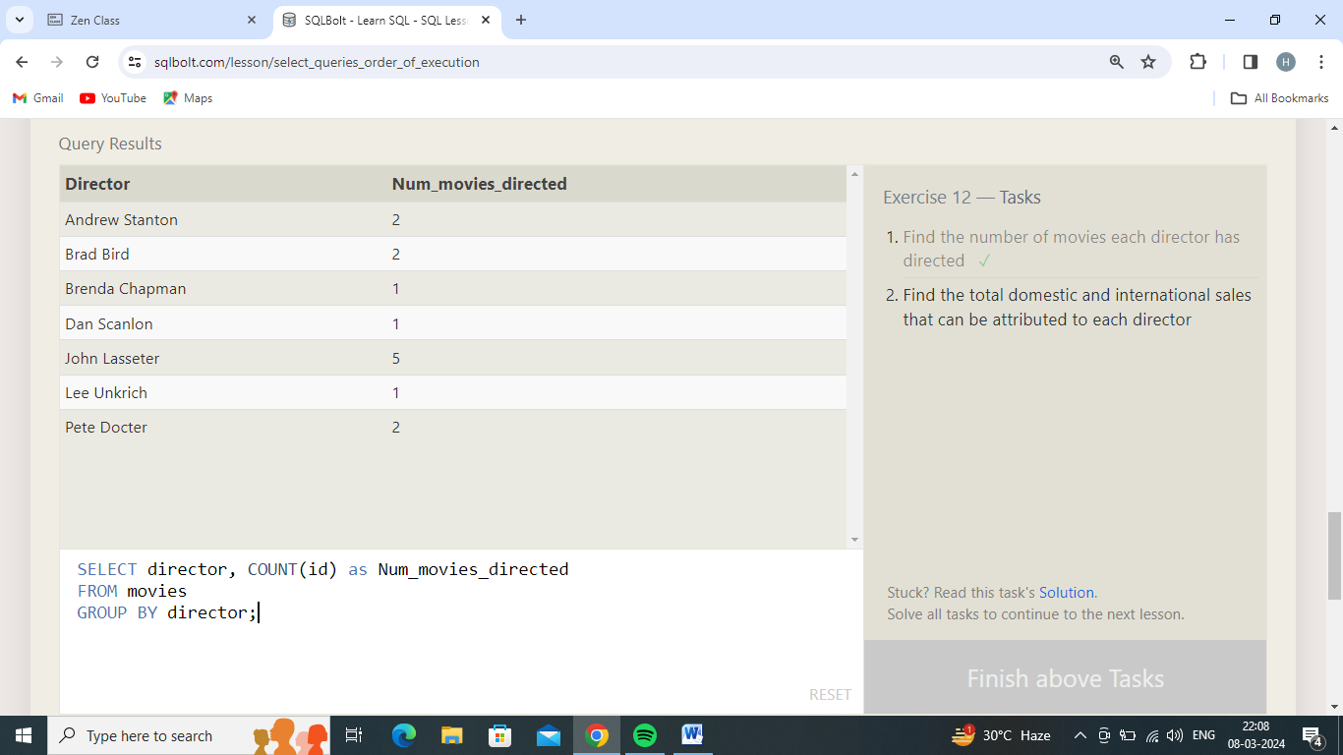

2.Find the total domestic and international sales that can be attributed to each director

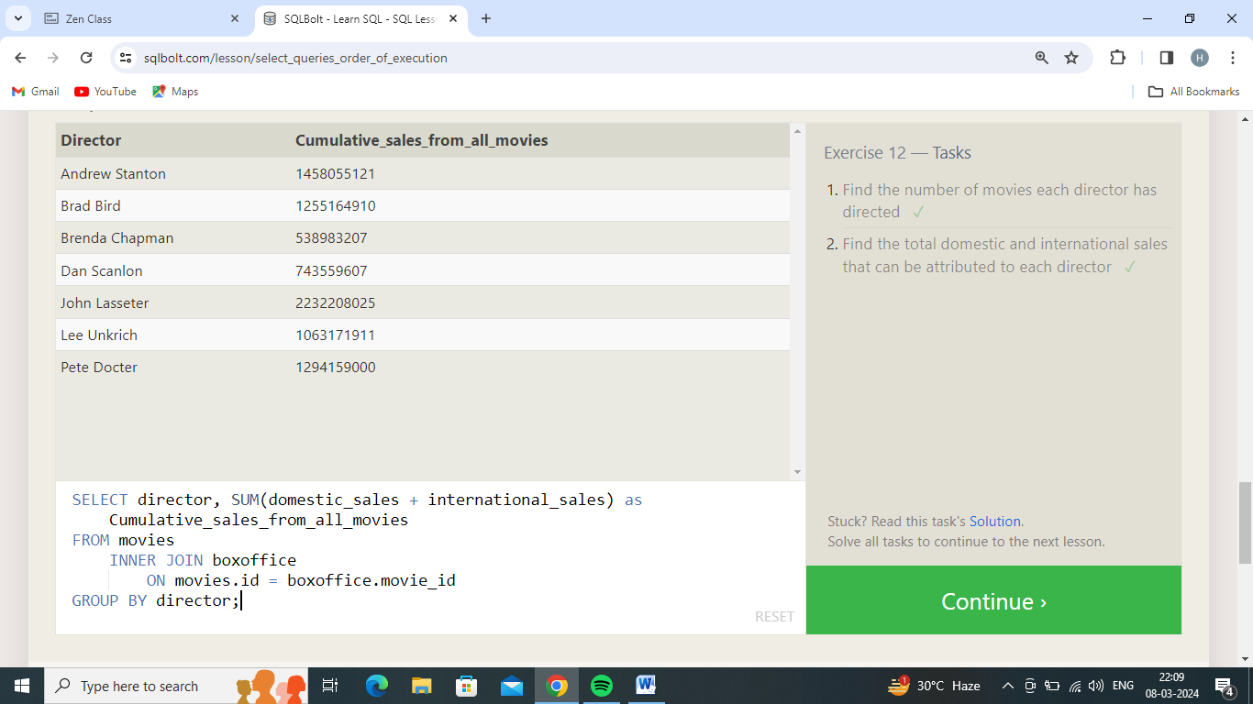

Exercise 13 — Tasks

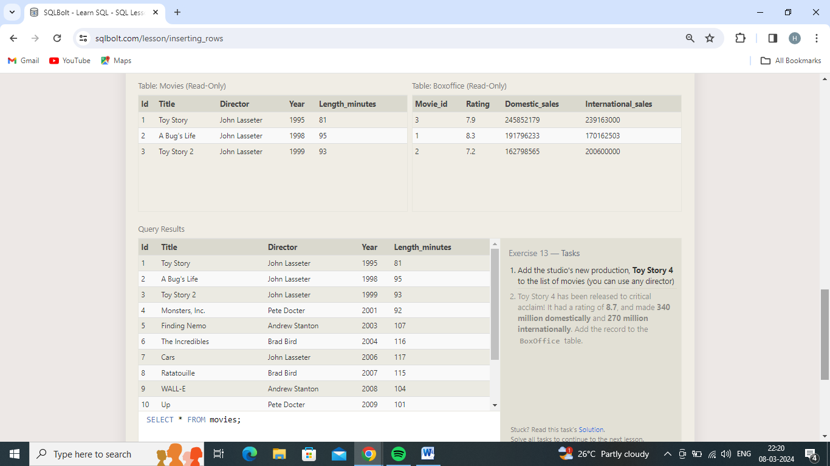

1.Add the studio's new production, **Toy Story 4** to the list of movies (you can use any director)

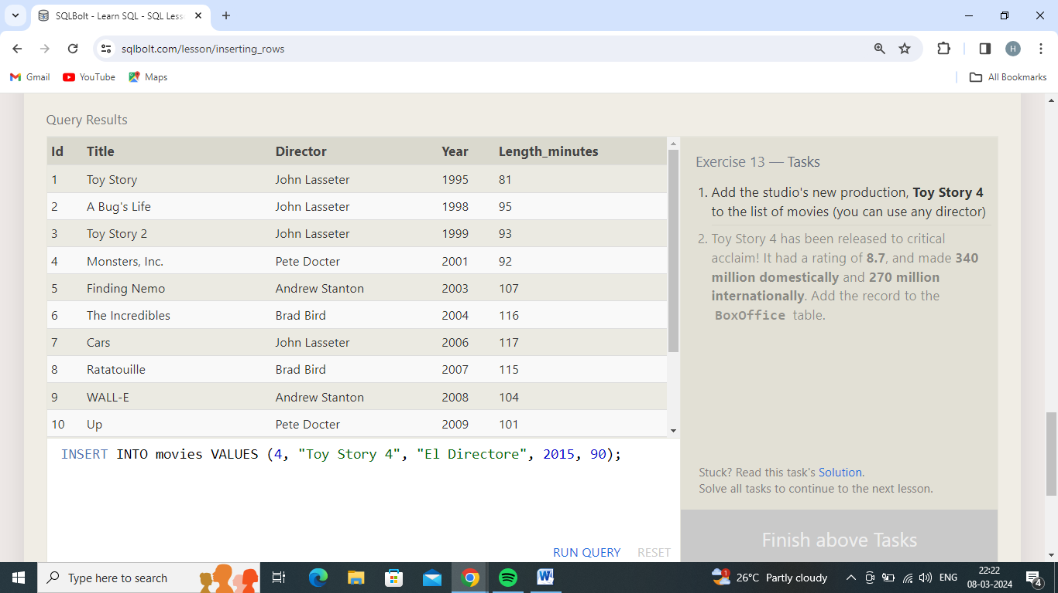

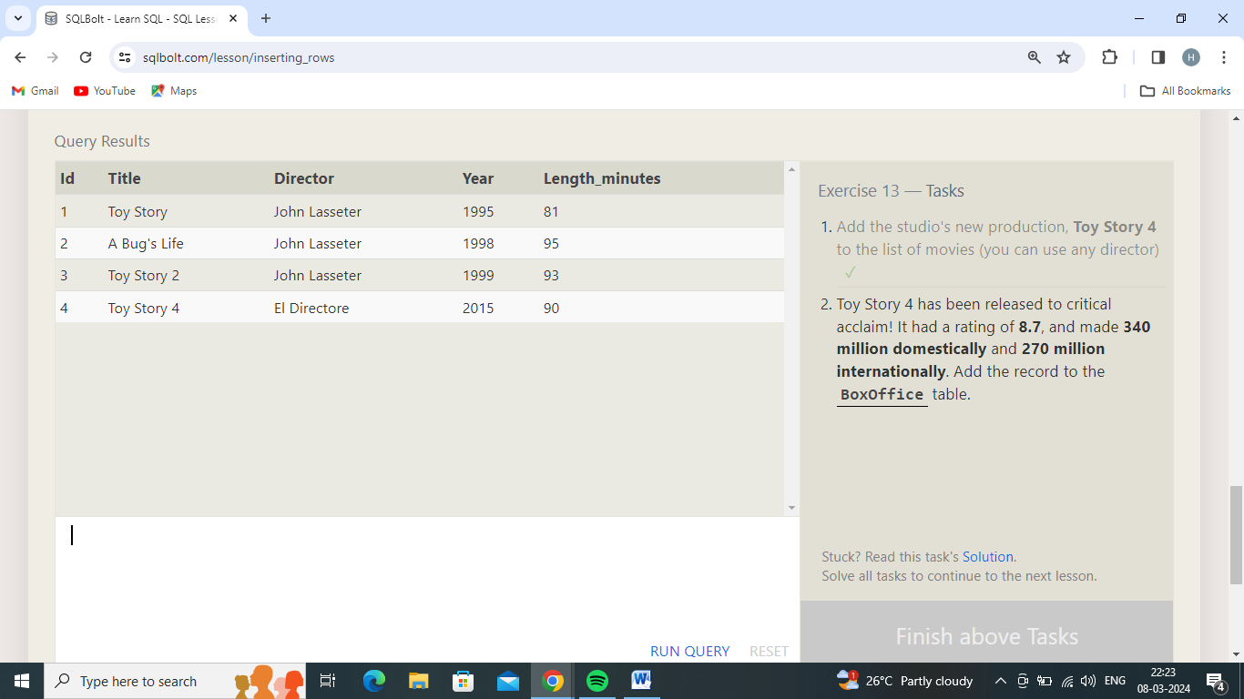

2.Toy Story 4 has been released to critical acclaim! It had a rating of **8.7**, and made **340 million domestically** and **270 million internationally**. Add the record to the **BoxOffice** table.

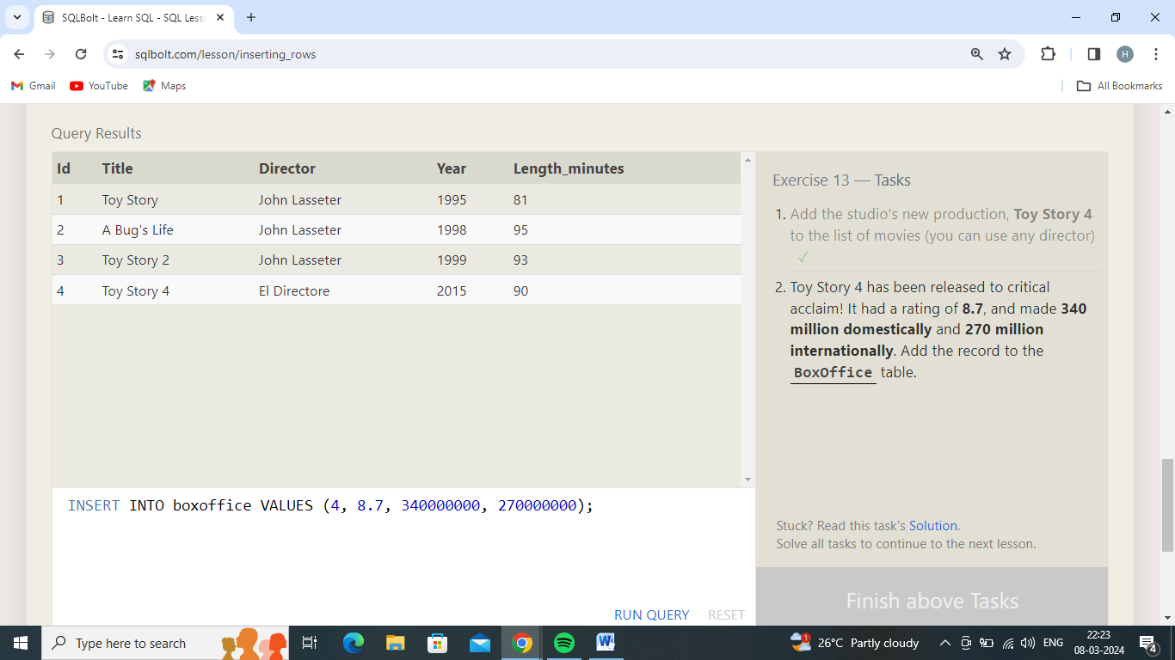

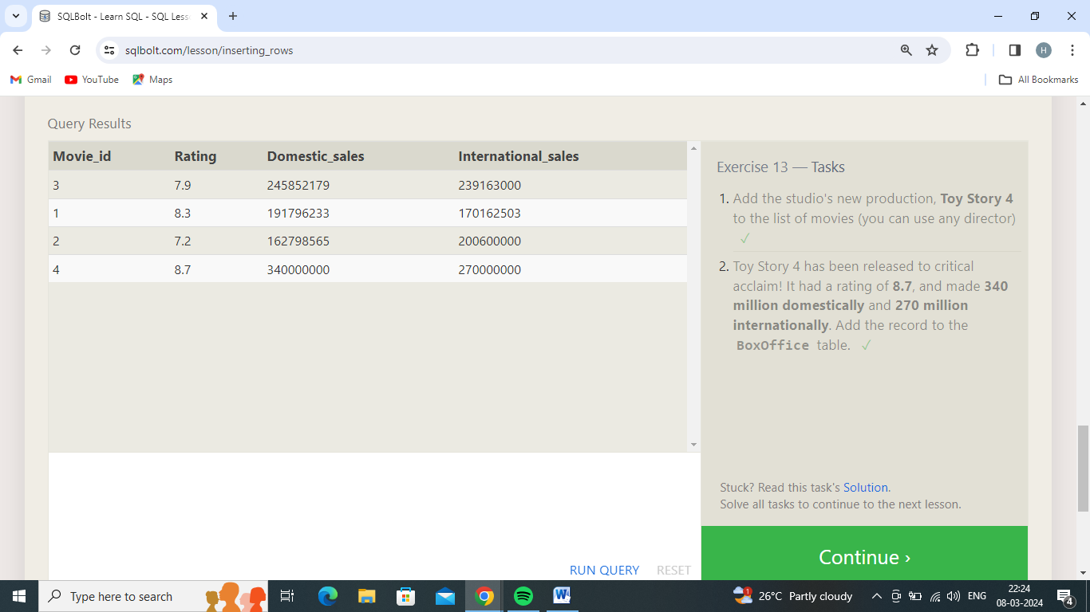

Exercise 14 — Tasks

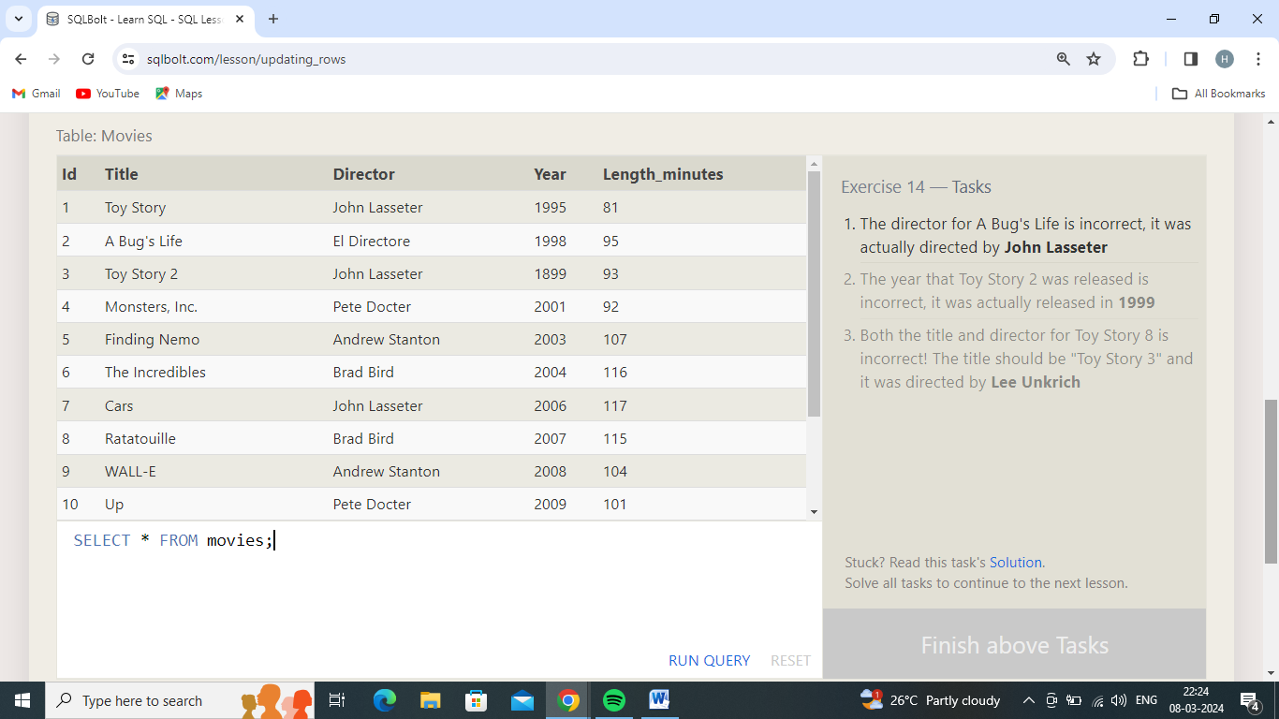

1.The director for A Bug's Life is incorrect, it was actually directed by **John Lasseter**

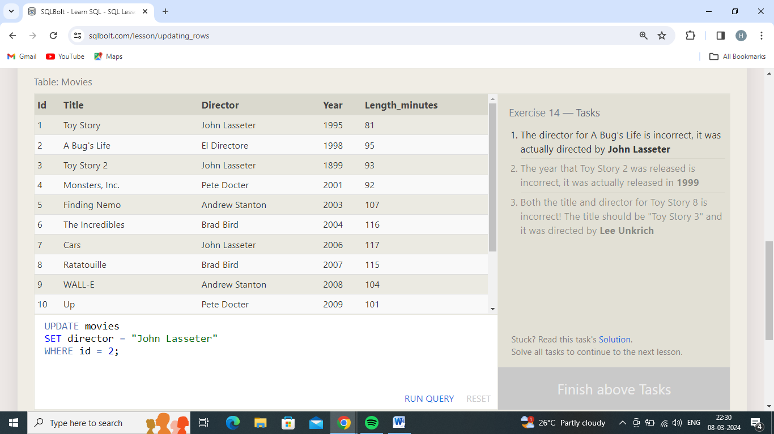

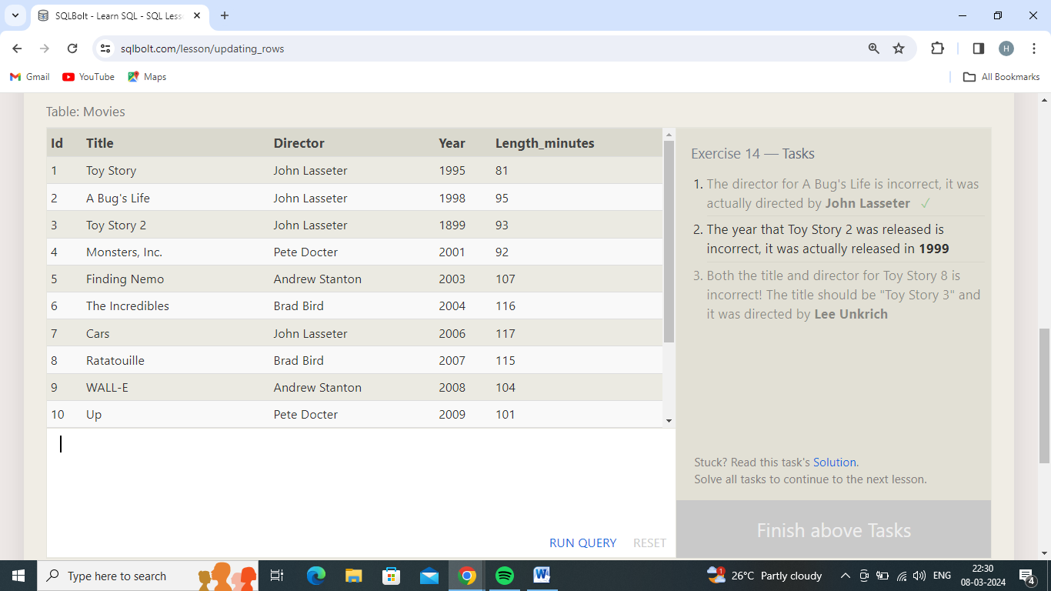

2.The year that Toy Story 2 was released is incorrect, it was actually released in **1999**

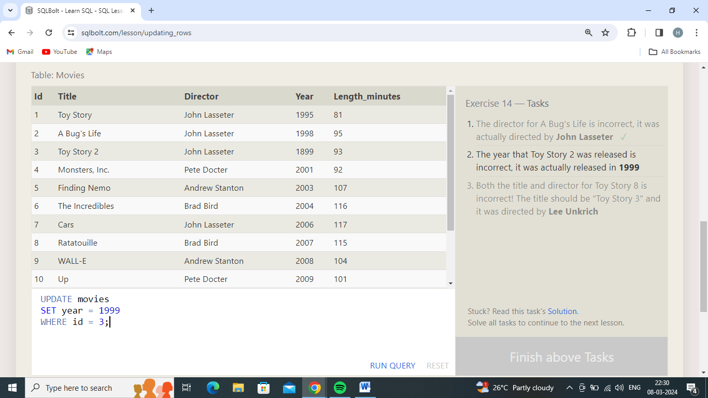

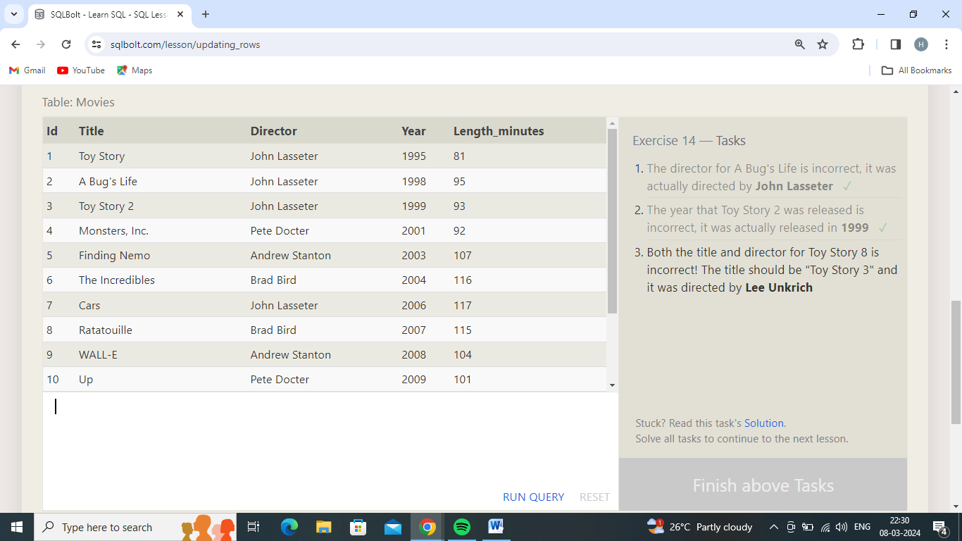

3.Both the title and director for Toy Story 8 is incorrect! The title should be "Toy Story 3" and it was directed by **Lee Unkrich**

